

**U-ACCESS PANTRY**

**Group- 2**

**Asmita Karale**

**Kunal Sahjwani**

**Rohini Deshmukh**

**MSIS 619 P 101 Systems Analysis and Design Fall 2022**

**Date: 12-13-2022**

**Contents**

1.0 Project Description……………………………………………………………… 01

2.0 Business Case…………………………………………………………………….03

3.0 Economic Feasibility……………………………………………………………..06

4.0 Revised Project Plan……………………………………………………………..08

5.0 Requirements

5.1 Requirement gathering sources…………………………………………..09

5.2 Requirement gathering technique and rationale…………………………..

5.3 List of functional requirements……………………………………………

5.4 List of Business Policies…………………………………………………..

6.0 Context Diagram………………………………………………………………….17

7.0 Data Flow Diagram……………………………………………………………….19

8.0 Use Case ………………………………………………………………………… 23

9.0 Class Diagram……………………………………………………………………..25

10. Activity Diagram………………………………………………………………….26

11. State chart Diagram……………………………………………………………….28

12. Sequence Diagram…………………………………………………………………30

13. Normalized Level 3 Data Model…………………………………………………..32

14. Privacy Component……………………………………………………………….35

15. Wireframes………………………………………………………………………..37

16. Methodology………………………………………………………………………50

17. Technical Recommendations………………………………………………………51

18. Summarized table based on feedback……………………………………………...52

***MOTIVATION***

*The reason why we thought of U-access as our project idea is because we three all being international students who have never been to the United States before and were struggling in our initial days to settle and locate stores from where we could purchase our necessary items. After attending orientation in the university, we got to know that there is a department called U-ACCESS who provide free necessary items to students every week by just using their id card. We were ecstatic about this initiative by the university. After frequently paying visits to the U-Access we noticed that a lot of our time is getting utilized in collecting the pantry items. At times we use to come to the university just to collect the necessary groceries that were needed and then come to know that they were out of stock. We felt this was very time-consuming and inefficient. Hence, we thought of easing this process for both the students and the U-access staff.*

**PROJECT DESCRIPTION**

Our suggested strategy is built to address the issues that University of Massachusetts students and U-Access pantry personnel confront in the real world. to make it simpler for everyone who works in the pantry, including students, to retrieve food from the pantry. The student must first visit the u-access, where staff will check them in and need them to present identification. After the staff has checked the student in, they will ask the student to complete a form on their phone. After the student fills out the form, staff members will accompany them downstairs to the pantry and ask them to wait in line before handing them the pantry. Although this procedure appears to be simple and straightforward, it has numerous flaws. What happens is when a student requests milk specifically, the supply runs out before they can obtain it. Both the staff and the students lose time and energy as a result of this. A significant amount of food is wasted as a result of the present grocery collection practice.

 We have thus developed a solution to these problems that would be advantageous to the student, the faculty, and the university as a whole. Our plan is to create an app that will enable students to shop for food if they run out of essential items in addition to collecting them. Transparency between the donors, the staff, and the institution will be ensured by the application we're proposing, which will also inform the student about which organizations have given what and how much of it. The application will function exactly like any other shopping application, The sole extra feature of the app is that students will have a choice between picking up their goods and shopping at the U-access pantry store. The app will provide an "out of stock" option whenever a product runs out in the pantry. The Hay Market sellers now enter the scene. As is common knowledge, Hay Market offers groceries at a very cheap rate.

The university will buy food in quantity from the vendors and then sell it to the students at a discount. By doing this, it will be made sure that the student won't have to go to the market or buy expensive groceries. Students at Umass Boston will have more job alternatives thanks to this concept. With this side venture, not only will the university make money, but it will also be very easy for the students to gather or buy goods.

**BUSINESS CASE FOR THE PROJECT**

***Current State***

* **Google Form Registration**

The current method asks the student to personally go to the u-access office, check in, and then fill out a form where the student will be asked numerous questions about what the student wants. The student is then taken to the pantry and is asked to wait until the staff hands over the pantry to them..

* **Front Desk Check- in**

The front desk check-in sometimes becomes very time-consuming since the staff has to manually make an entry in their system every time a student goes to the pantry to collect groceries

***Impact***

* **Long waiting for check-in**

 On Tuesdays, especially there is a huge crowd at the U-access office, this results in standing for hours just to get the check-in process done which ultimately results in delay in getting the groceries.

* **Resource Shortage**

Many times students go to the  U-Access to take some particular groceries that they are in need of. But are now aware of the fact that the staff has that particular supply. This results in a waste of time for both the student and the staff which ultimately results in food wastage.

* **Food wastage**

The very common problem that they face on a daily basis is that they find it inconvenient that students come to them in groups to collect the pantry. Since there is a shortage of staff in the U-Access it becomes very difficult for them to handle a dozen of students at a time

***Desired State***

* **User Friendly**

The proposed application is similar to existing shopping apps available. Hence it is very user-friendly and can ease the process of pantry collection for the students.

* **Transparency within the system**

Since the students are not aware of where the donation comes from, how much an organization has donated and what, the students can’t really make a decision whether they should place an order from the pantry or not. If the application sends notifications to the students about who has donated what and how much, this could make things easier for the students and will also ensure transparency.

* **Groceries at a minimal cost**

Even if any student is unable to collect donations from the U-access because of unavailability of supplies then the student has an option of shopping the groceries from the U-access store rather than shopping for expensive ones

***Other Alternatives***

* **Bring in more donors**

Hire a marketing team to bring in more donors. The U-access personnel also struggled to convince organizations to give products to the university, which was a significant problem. Hiring a marketing team to persuade the organizations to make donations to the institution is what can be done in this situation. However, employing a marketing team is a trial-and-error process; it sometimes succeeds and sometimes fails. Consequently, the university cannot bear such a risk., the university cannot bear such a risk.

**ECONOMIC FEASIBILITY**

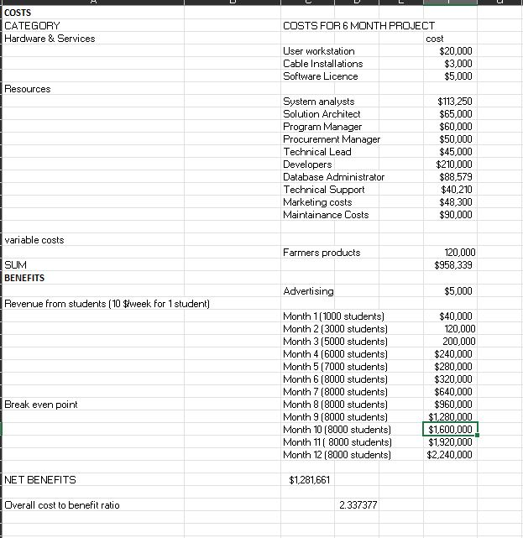

**Economic feasibility**

We have presented the costs and benefits of the table above. We plan to hire the above resources and have a 6 month timeline for the project.

After deployment, we target hitting 8000 students by the 8th month with just 10$ per student per week. At the 8th month the net costs become same as net benefits and we break even.

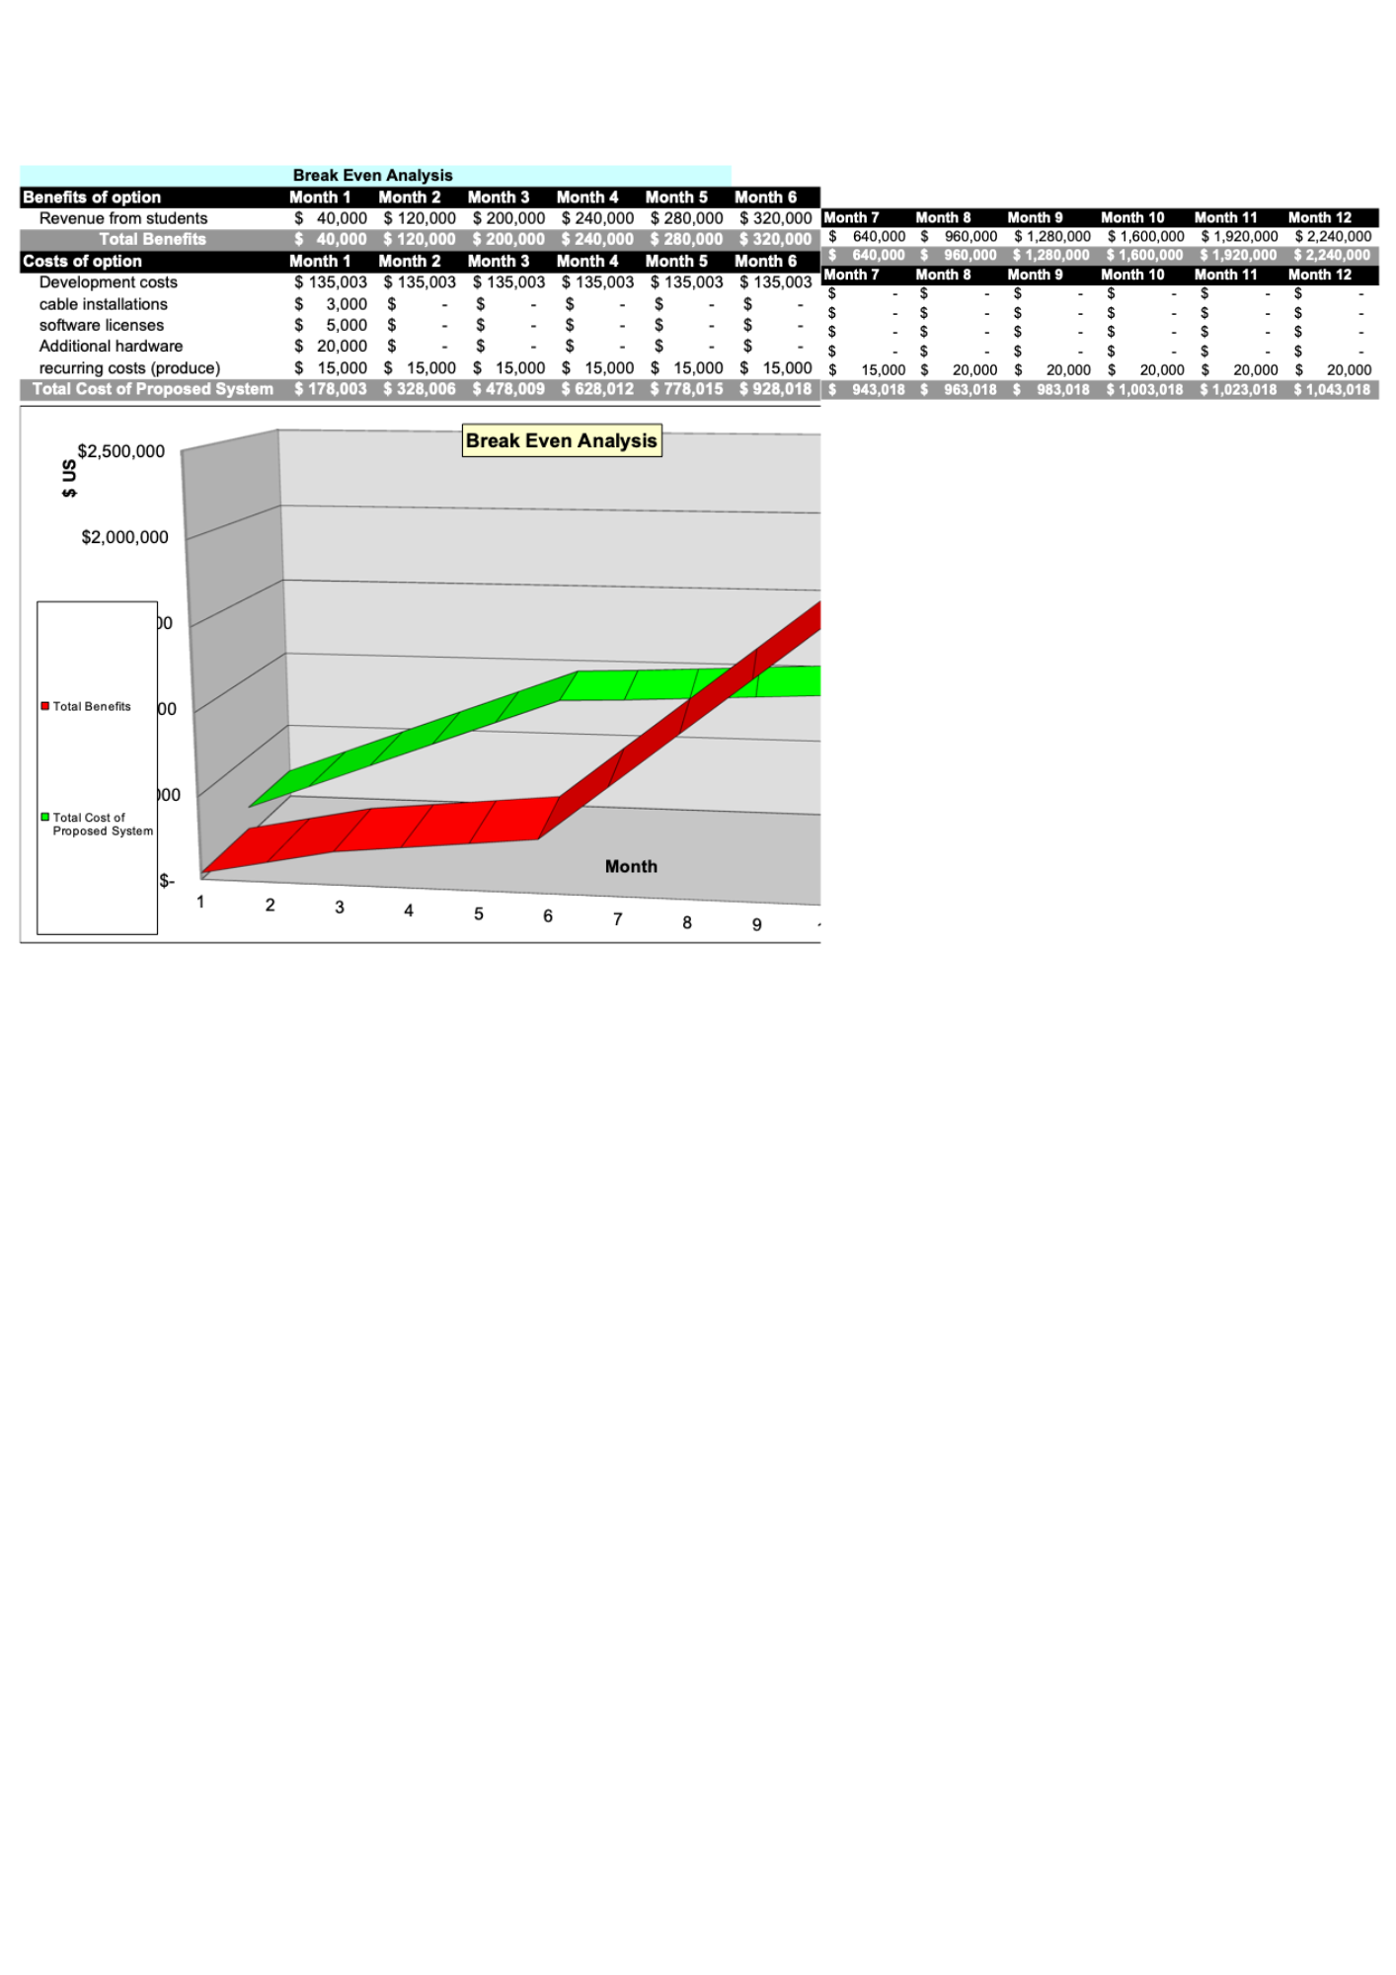

Our breakeven analysis showcases the detailed analysis and graph of the net benefits to net costs of the proposed project

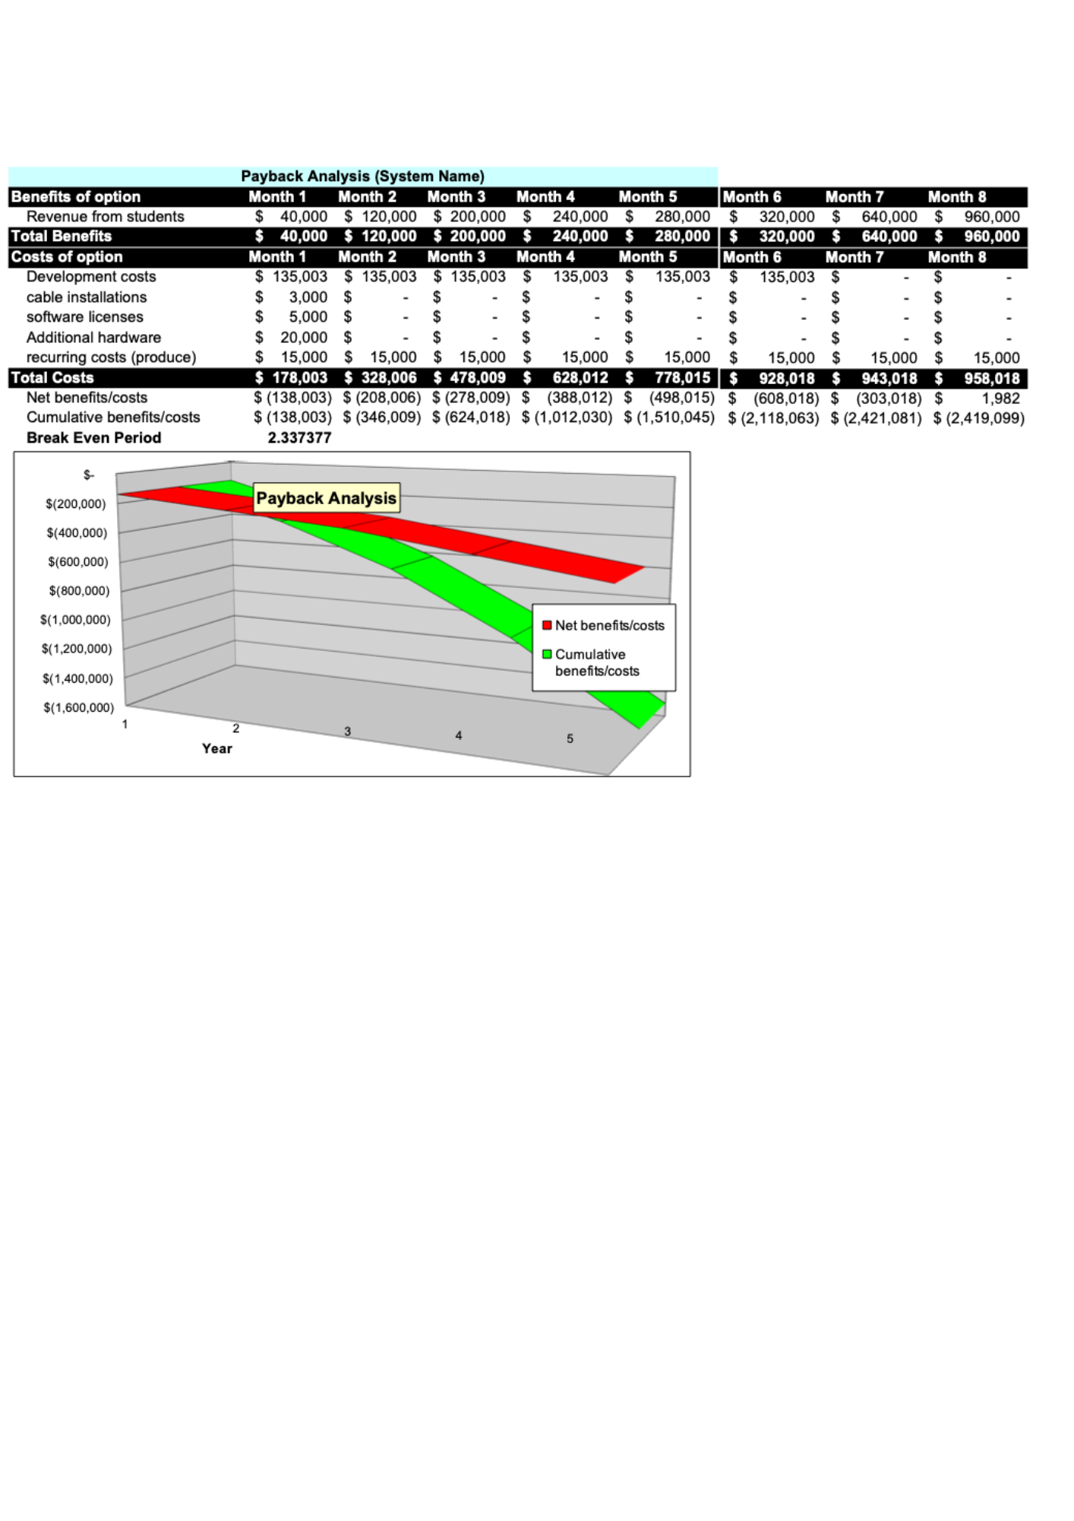**REVISED PROJECT PLAN**

**GANTT CHART**

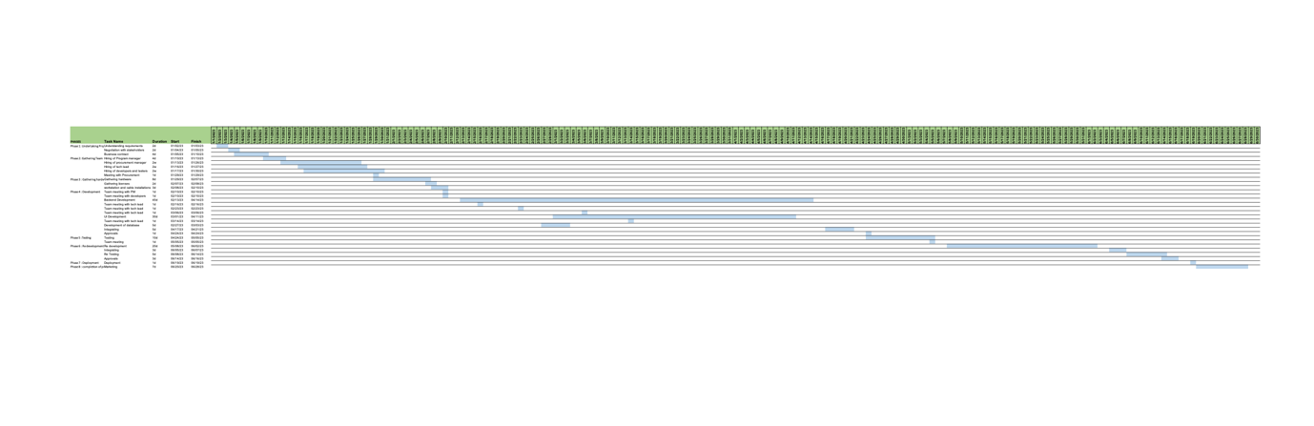

**REQUIREMENTS**

1. ***Requirement gathering sources***
2. **Interview with program coordinator:**

We had a discussion with the head of U-Access. From her we got to know that the staff of U-Access face a major set of problems. The very common problem that they face on a daily basis is that they find it inconvenient that students come to them in groups to collect the pantry. Since there is shortage of staff in the U-Access it becomes very difficult for them to handle a dozen of students at a time. Our proposed system will help overcome this issue.

1. **Student Survey form (Google form):**

After getting to know the problems of the U-access staff we targeted the students to get their perspective of this whole pantry collection procedure. We learnt that students are also facing quite some problems with the current way of pantry collection. Every time a student goes to the pantry with an expectation that the student will get the items that he/she needs. But the student is not aware if that particular item is available or is out of stock or has not been donated at all. This results in wastage of time for the students.

1. **Cost Estimation for salary via Google:**

The salaries for the resources are an estimate according to their job role. These estimations were provided by taking a reference of google.com . We have also provided the estimation of hardware, software and cable installation by taking reference from the same website. All the resources would have an inhouse employment, ie students from Umass Boston to save the development costs and provide a platform for the students of the university.

1. ***Requirement gathering Techniques and rationale***
2. **Requirement gathering techniques**

We created a google form and circulated amongst the students who take pantry every week. After viewing the results we got to know that 93.33% of the students have no issue in buying the groceries from the university at cheaper rate if they don’t get the same groceries from pantry.

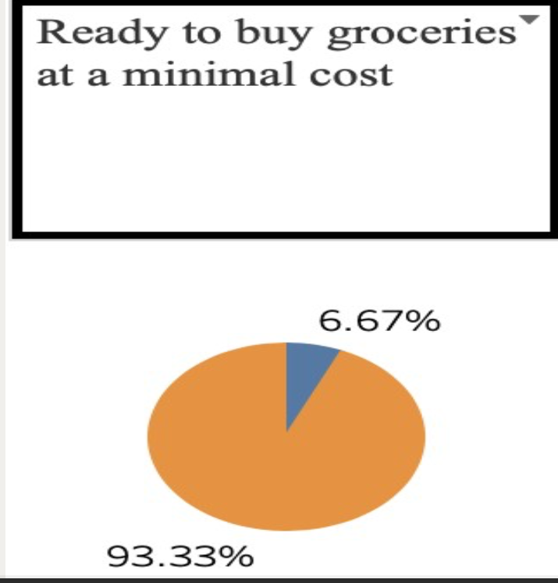

1. **Rationale:**

The reason why we collected this data is because we wanted to make an analysis of what all problems the students are facing, how many students are facing , what are the most common issues out of all and what do the students expect as an alternative from the university.

1. ***Functional requirements –***

1. The student who is already a registered member should not be registered again i.e no duplicate ID’s should be created for the student as well as the staff. T
2. The student should be able to view all the donations in the donation tab
3. The product which is out of stock should not have the functionality of adding it to the cart. The products added to the cart by the user should be visible to the student.
4. Donations should be limited to only one type of product per student.
5. The cart value should have accurate calculations so that there is no discrepancy while between the view price and the sale price.
6. The payment should follow accurate 2FA authentication to keep the transactions secure.
7. Order receipt should be generated for every order.
8. ***Non- Functional Requirements***
9. The application should look user friendly and not too complicated for the user.
10. The application should be easily accessible for the staff
11. The application should look aesthetic
12. The application should be able to handle the traffic of about 16000 students
13. The application should have a theme related to food products
14. The application should be able to run on low internet connectivity as well
15. ***Business Policies***
16. **Student of UMASS**

For any one who wants to shop from Umass pantry store or wants to collect pantry from U-Access that person has to be a student of University of Massachusetts, Boston. The application will ask the student for its umb id and umb email address while logging in and signing in the app

1. **Single registration**

One student cannot be registering twice. There should only be one entry per student

1. **Per Student one Donation (FIFO)**

The donation will follow the first in first out method. Any one who orders first will be getting the pantry as he/she wants.

1. **Breach of Student Confidentiality will result to a lawsuit**

The application will ensure confidentiality of student details, failing to do so will result in a lawsuit.

1. **Hardware managed by the procurement manager**

The retail of any hardware or software should be made by the approval of the procurement manager, as the procurement manager is responsible for the retail of the same. If any retail is made without the approval of procurement manager the company shall not be responsible for the reimbursement of the products.

1. **Ensuring the safety of the food supply**

None of the products should not pass the expiry date. Staff has to ensure the freshness of the product. Failing to do so could result in the termination of the staff member.

1. **Failing to collect order, penalty to student**

If a student requests items from pantry and if the student fails to do so, the student will be charged with a penalty fee of 10$

**WORK BREAKDOWN STRUCTURE**

|  |  |  |  |
| --- | --- | --- | --- |
| No. | Task | No. of days | Date |
| 1. | Understanding requirements | 02 | Mon 1/2/23 Tue 1/3/23 |
| 2. | Negotiation with stake holders | 02 | Wed 1/4/23 Thu 1/5/23 |
| 3. | Business contract | 04 | Thu 1/5/23 Tue 1/10/23 |
| 4. | Hiring of Program manager | 04 | Tue 1/10/23 Fri 1/13/23 |
| 5. | Hiring of procurement manager | 10 | Fri 1/13/23 Thu 1/26/23 |
| 6. | Hiring of tech lead | 10 | Mon 1/16/23 Fri 1/27/23 |
| 7. | Hiring of developers and testers | 10 | Tue 1/17/23 Mon 1/30/23 |
| 8. | Meeting with Procurement | 01 | Mon 1/30/23 Mon 1/30/23 |
| 9. | Gathering hardware | 08 | Mon 1/30/23 Wed 2/8/23 |
| 10. | Gathering licenses | 02 | Tue 2/7/23 Wed 2/8/23 |
| 11. | Workstation and cable installations | 03 | Wed 2/8/23 Fri 2/10/23 |
| 12. | Team meeting with PM | 01 | Fri 2/10/23 Fri 2/10/23 |
| 13. | Team meeting with developers | 01 | Fri 2/10/23 Fri 2/10/23 |
| 14. | Backend Development | 45 | Mon 2/13/23 Fri 4/14/23 |
| 15. | Team meeting with tech lead | 01 | Thu 2/16/23 Thu 2/16/23 |
| 16. | Team meeting with tech lead | 01 | Thu 2/23/23 Thu 2/23/23 |
| 17. | Team meeting with tech lead | 01 | Mon 3/6/23 Mon 3/6/23 |
| 18. | UI Development | 30 | Wed 3/1/23 Tue 4/11/23 |
| 19. | Team meeting with tech lead | 01 | Tue 3/14/23 Tue 3/14/23 |
| 20. | Development of database | 05 | Mon 2/27/23 Fri 3/3/23 |
| 21. | Integrating | 05 | Mon 4/17/23 Fri 4/21/23 |
| 22. | Approvals | 01 | Mon 4/24/23 Mon 4/24/23 |
| 23. | Testing | 10 | Mon 4/24/23 Fri 5/5/23 |
| 24. | Team meeting | 01 | Fri 5/5/23 Fri 5/5/23 |
| 25. | Re development | 20 | Mon 5/8/23 Fri 6/2/23 |
| 26. | Integrating | 03 | Mon 6/5/23 Wed 6/7/23 |
| 27. | Re Testing | 05 | Thu 6/8/23 Wed 6/14/23 |
| 28. | Approvals | 03 | Wed 6/14/23 Fri 6/16/23 |
| 29. | Deployment | 01 | Mon 6/19/23 Mon 6/19/23 |
| 30. | Marketing | 07 | Tue 6/20/23 Wed 6/28/23 |

**AS IS CONTEXT DIAGRAM**

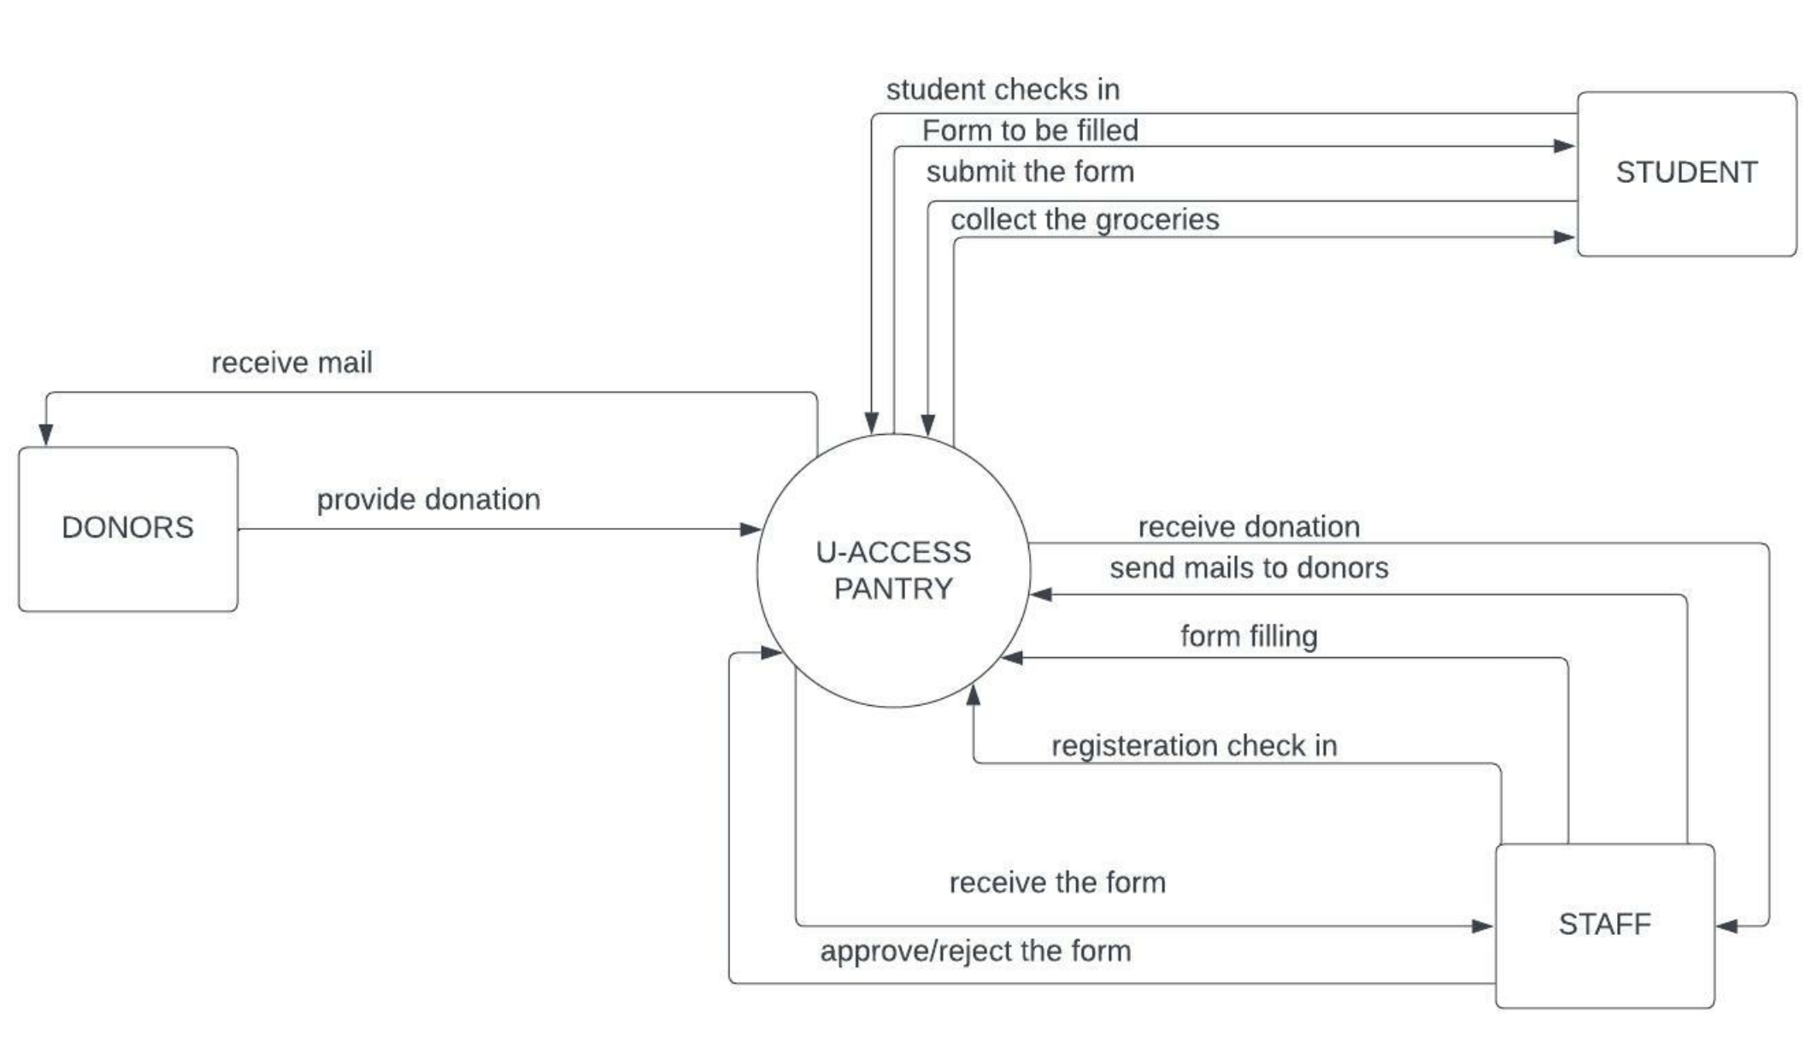

U-Access Pantry is the System where the students, Staff and Donors are the entities which interact with our system. The student contacts the U-access office where the staff physically checks in the student after which he is provided with a google form and the student adds his required groceries. After the form has been submitted, it is viewed by the staff and the staff provides the student with a token number and is assigned to a staff member who takes the student to the pantry where he can get his required groceries which were filled in the google form.

**TO BE CONTEXT DIAGRAM**

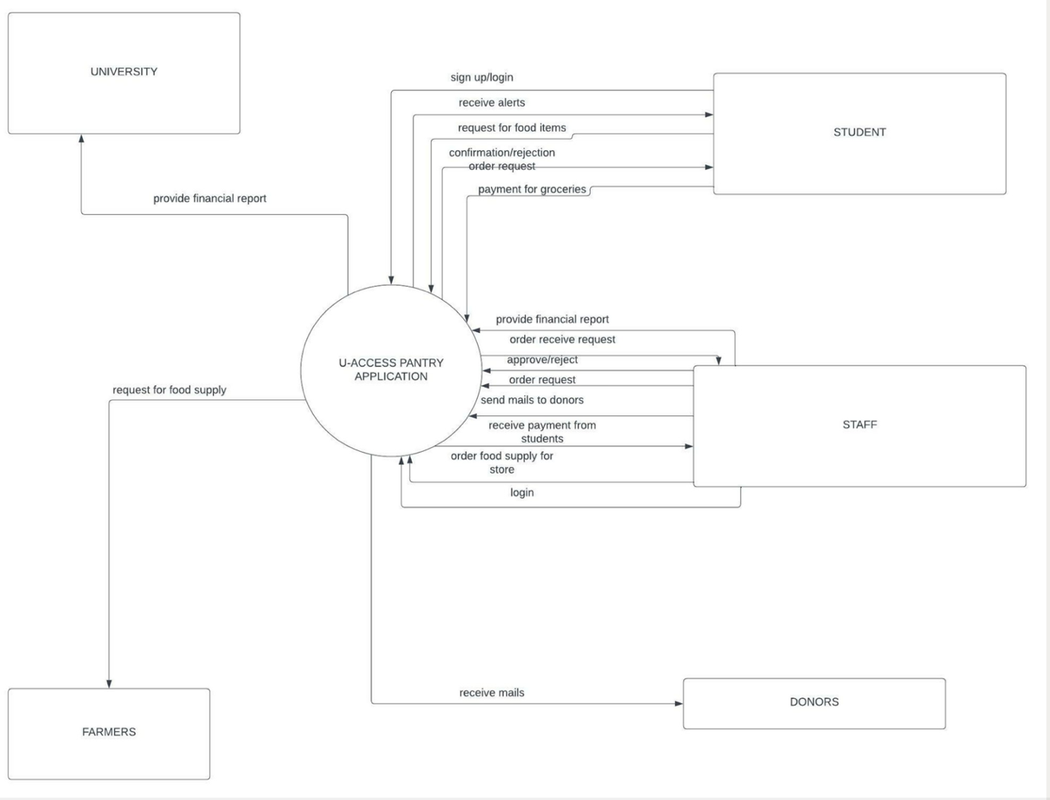

The main system we have here is the U-Access pantry which is the application. The user will first have to register to the app by creating an account and if the user already has an account then the user can simply login. After the user has created their account or has logged in the user will receive alerts about donations, who has donated what, when, how much. The student will when requests for food items the staff will confirm this request of the user via the app and send notification if they have received the order or not. The user will then do the payment which will be received by the staff. The staff will generate a monthly report of the finances and will send that report to the university every month in order to keep track of the finances and profit and loss. The staff will also send emails to donors asking them to donate to the university and the donors will receive this mail. The staff will see if any items are running out from the u-access store if so the staff will order more supply from the farmers.

**DATA FLOW DIAGRAM WITH TWO LEVELS OF DECOMPOSITION**

**LEVEL 0 DFD**

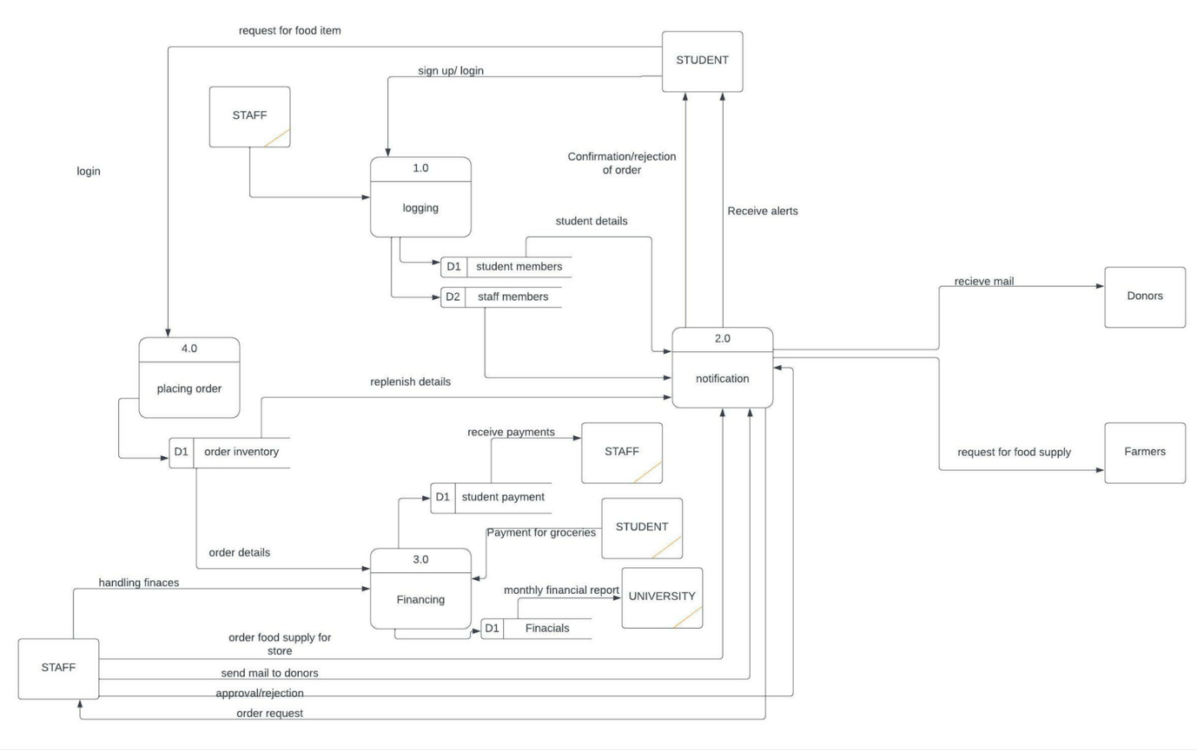

The data flow diagram for level 0 was built on the basis of 'to be context diagram'. The processes were broken down to show the flow of data between the processes. The boxes with a title are the major processes of the system as referred from the context diagram. The open boxes are called datasets where the data is saved. The boxes without titles are the actors from the use case who would interact with each other using the system and have an exchange of data using these processes.

**LEVEL 1 FOR “Placing order”**

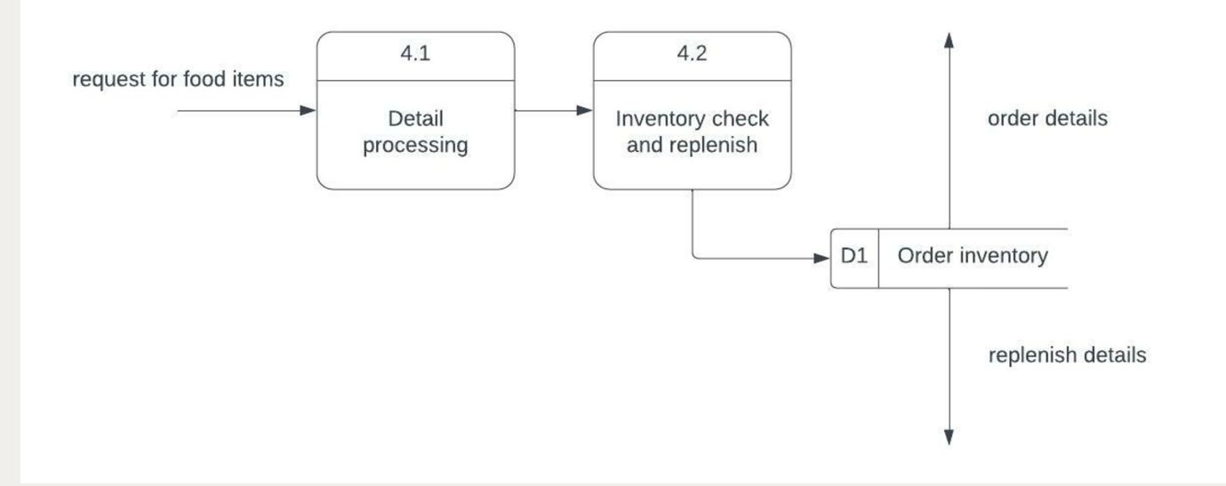

**Placing Order:**

We have further broken down the process of the placement of order which is our level 1 Data flow diagram for this process. The food items requested are processed and the cart is id is created. After which the inventory data is pulled and is processed with the cart id. This data is pulled for replenishment of the inventory and for payments.

**LEVEL 1 FOR “Financing”**

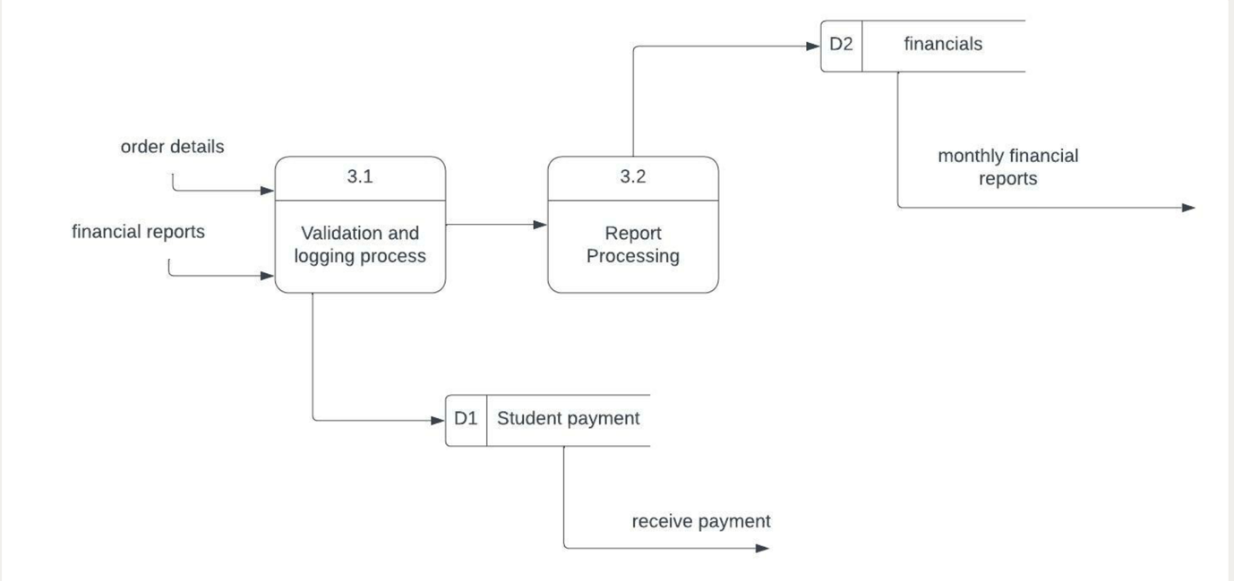

**Financing:**

the financing process is also broken down to level 1 data flow diagram. For financing the order details are pulled in for the process of payment with the cart ID. After which the payment is processed. The payments should be secured and encrypted with hashing and 2FA authentication should be used to process the payment.

**LEVEL 1 FOR “Logging”**

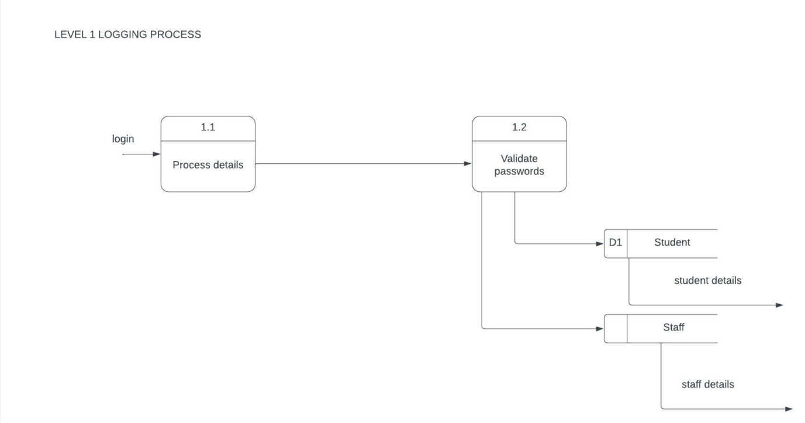

**Logging**

The process for logging in was broken down to a level 1 Data flow. The details were taken into the system from the user, the passwords are validated by matching the entered password to the password stored in the data set, If the credentials match the user is given their respective access to the system.

**USE CASE DIAGRAM**

**AS IS**

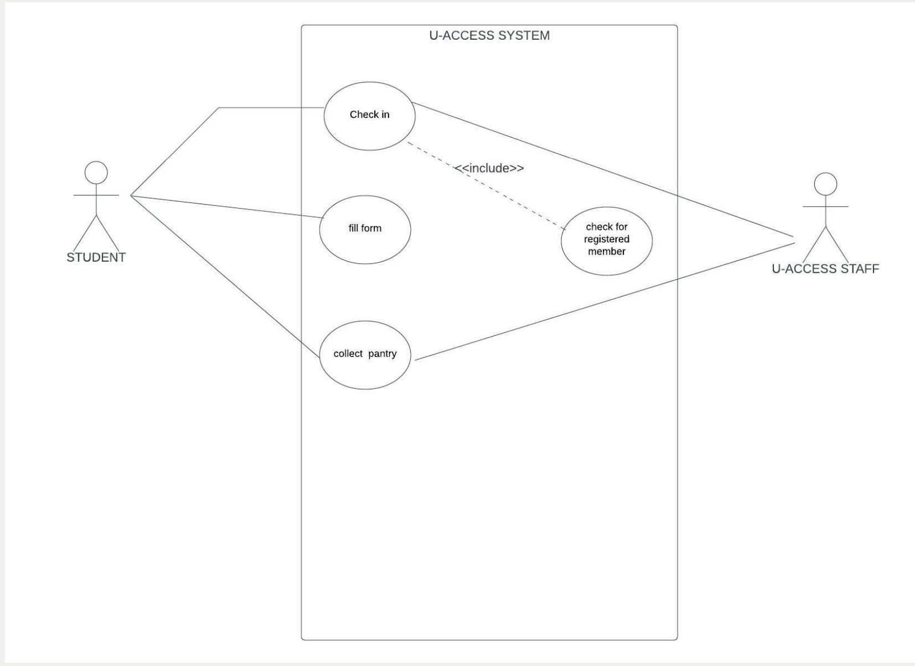

We have two actors in the current system: Primary Actor: Student i.e., the initiator

Secondary Actor: U-Access Staff who do all the check-in processes for the system.

We have included checking registered members because the student must register before they can get donations. After checking in they need to fill up the on-desk form post which the secondary actor can get them the groceries

**TO BE USE CASE**

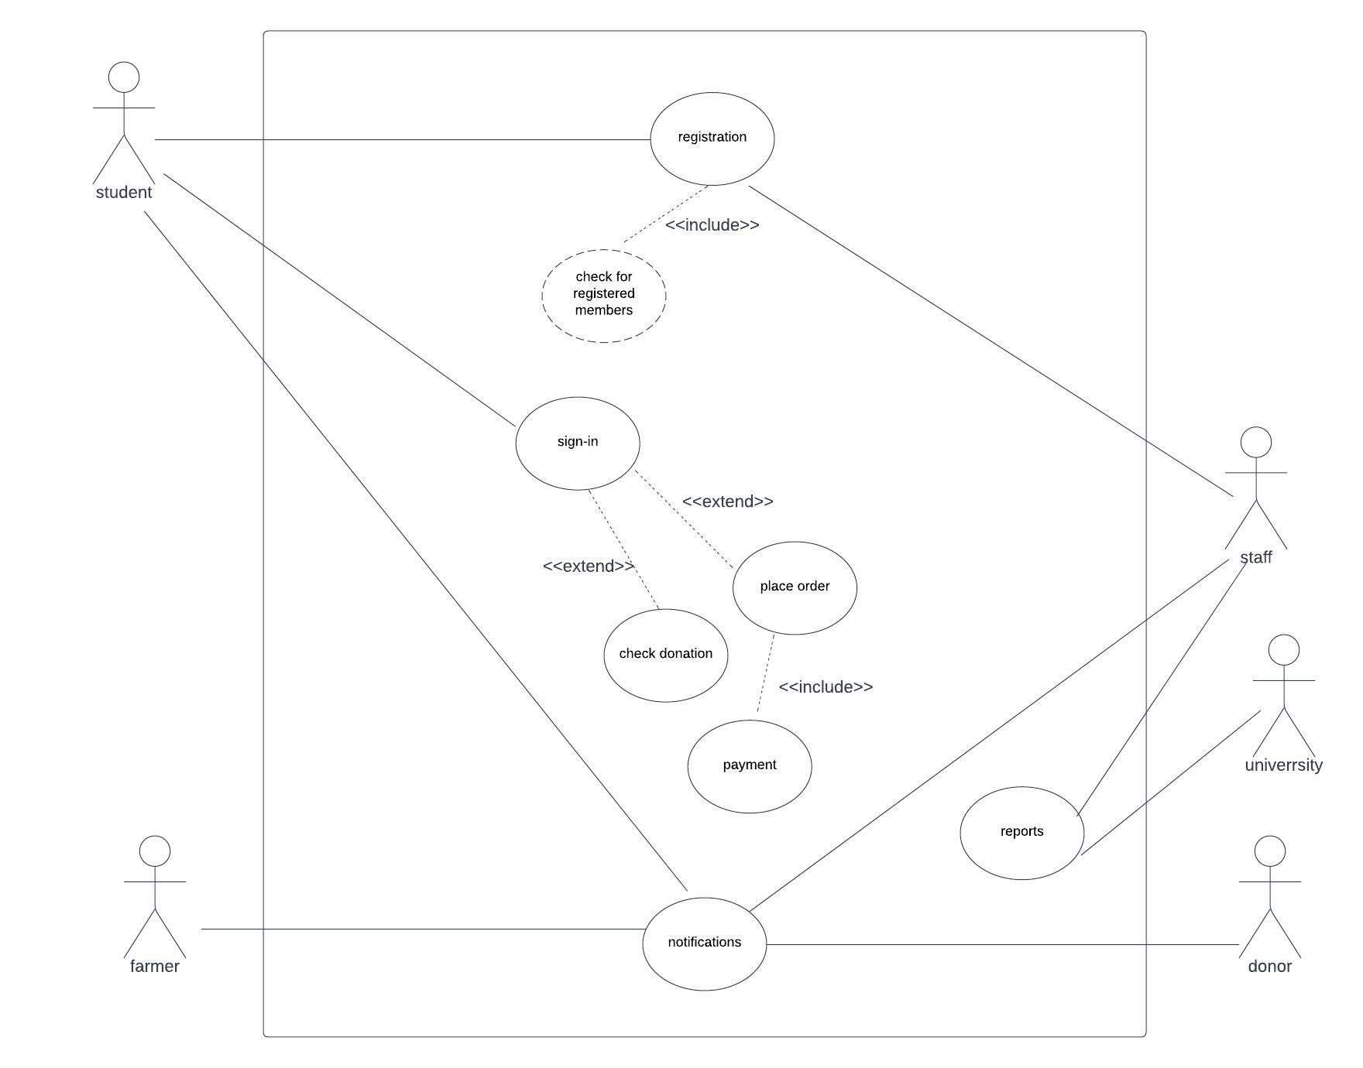

In the To be use case, there are five actors to achieve maximum transparency. The five actors are student, staff, farmer, donor and university. The student uses the system by registering which has an include for checking registered members which means every time a student logs in the system will check if the user is a registered member or not and would have to sign up. The student would then log in to the portal can either place the order or check the donations or do nothing. If the student wants to place the order then the payment is must and is connected to the cart with an include. The students would also receive notifications from the farmers and donors when the donations and inventory is updated.

**CLASS DIAGRAM**

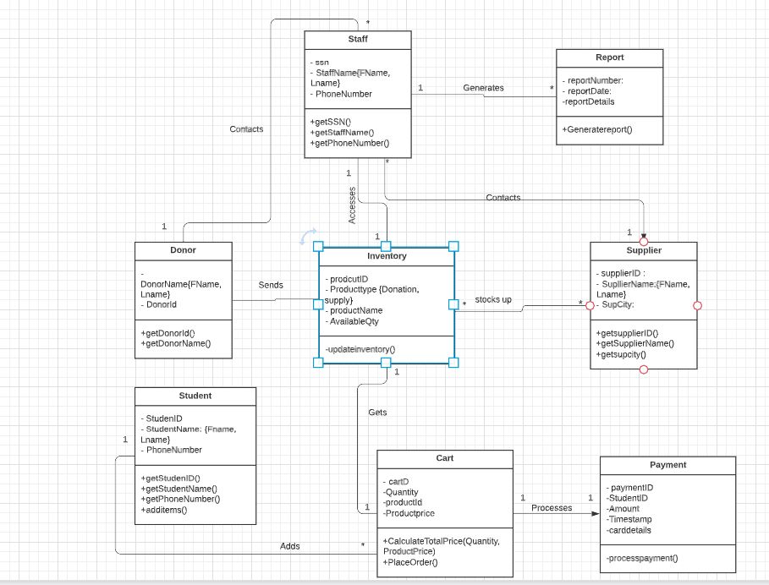

**Class diagram:**

Our class diagram has the working of the system interacts with each other and gives a clearer idea for the developer to develop the project. The staff object communicates with the donor and supplier for inventory. the inventory object is connected to the staff for inventory updation The student interacts with the cart to add items which is further connected to payment to get the payment for the items that have been ordered.

**ACTIVITY DIAGRAM FOR PLACING ORDER**

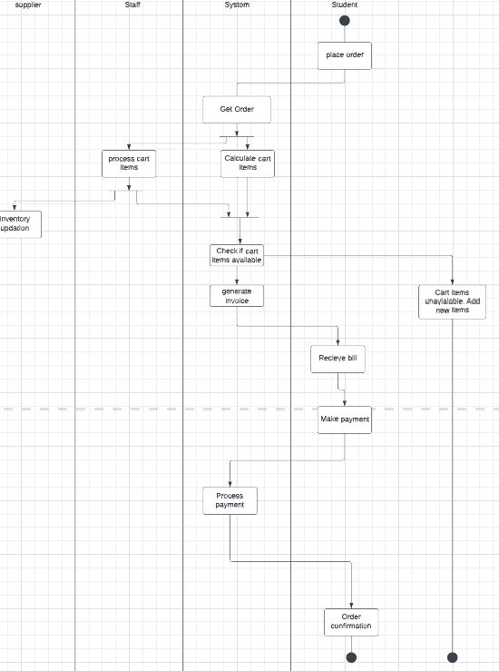

We have updated the Activity diagram as per the negative scenario as well

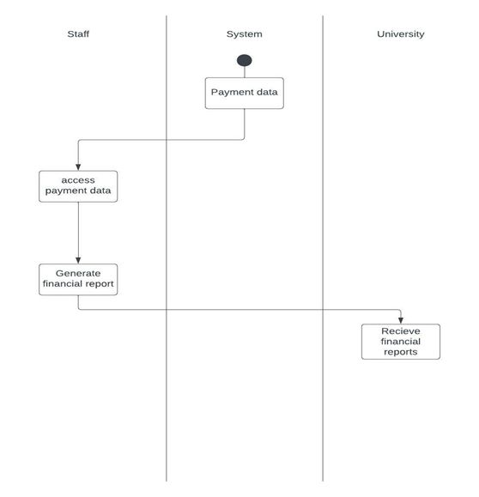

**ACTIVITY DIAGRAM FOR SENDING REREPORTS**

**STATE CHART DIAGRAM for LOGGING**

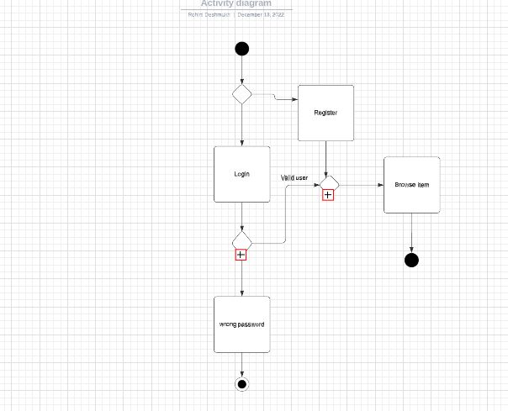

In the above state chart diagram is for the login of the student to the system. If he/she is a valid student with the correct credentials they have access to browse the item add to cart and end the process by making the payment.

If a student is a new to system they have to register first, a valid UMASS student can access the application. And if the credentials are incorrect the message gets popped up as “Wrong Password” and they are send back to the home screen and thus the end of the process.

**STATE CHART DIAGRAM for DONATION AVAILABILITY**

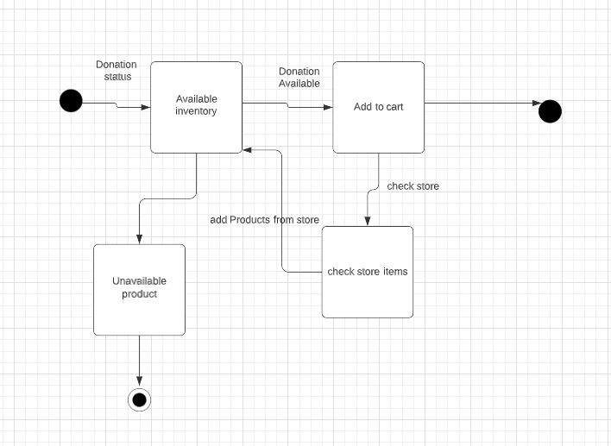

The above is to check donation availability in the application, the student will check the donation tab if it is available they will add the items in the cart and proceed to checkout and end the process. If the donation runs out the student still have access to the store where they can check the store availability and add the items for the same. If the product the student wish to buy is unavailable the process ends.

**SEQUENCE DIAGRAM FOR ORDER PLACEMENT**

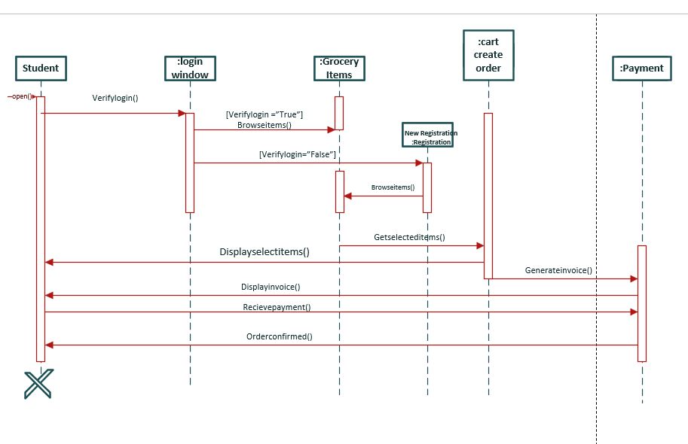

**Sequence :**

Our sequence diagram is for order placement. The student first logs into the system where the login window is created. If the student is a registered member he is able to browse the items and create the order id instance, otherwise another instance is created with new registration and the student is registered after which he can browse items and create the order instance which would lead to payment and get the receipt after the order is confirmed

**SEQUENCE DIAGRAM FOR REPORT GENERATION**

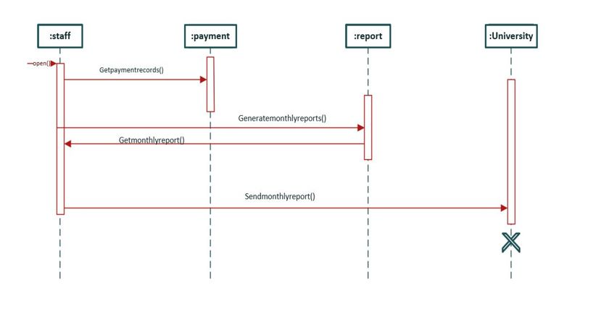

**Sequence 2 (report generation):**

Here the staff member who has access to the system logs in to the system where the staff object is called after which the payment is called to get payment records. Further the reports are generated in the system which is sent to the university.

**NORMALIZED LEVEL 3 DATA MODEL**

**0NF**

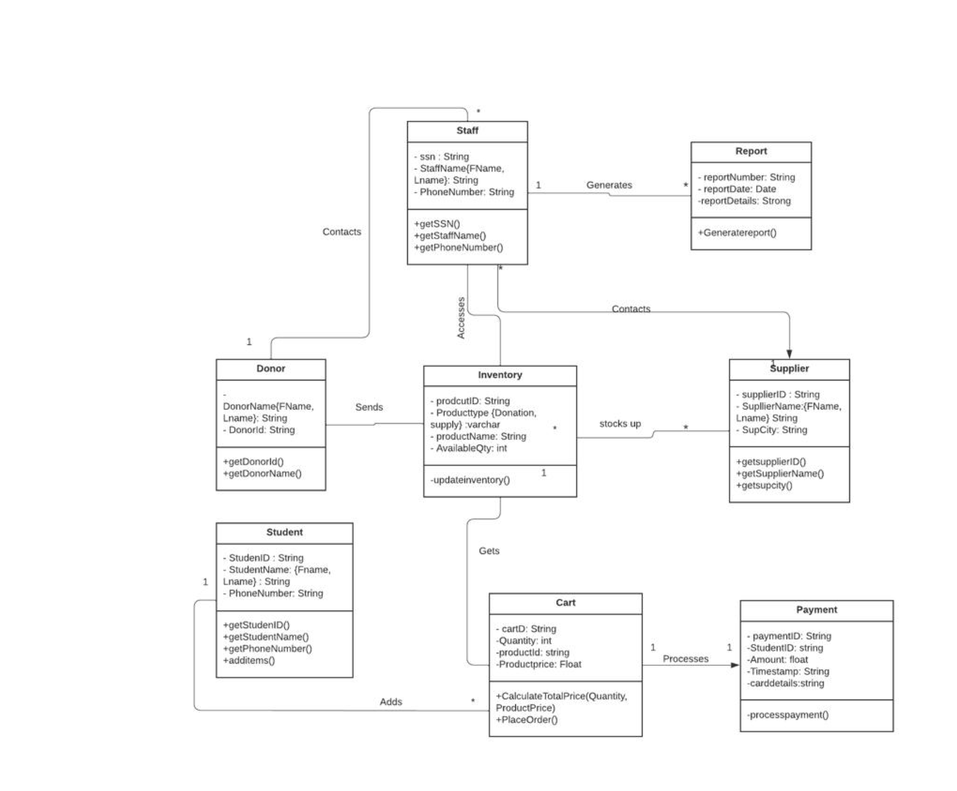

This data model is the 0 normalised form of the class diagram. Here all the attributes are given datatypes.

**1NF**

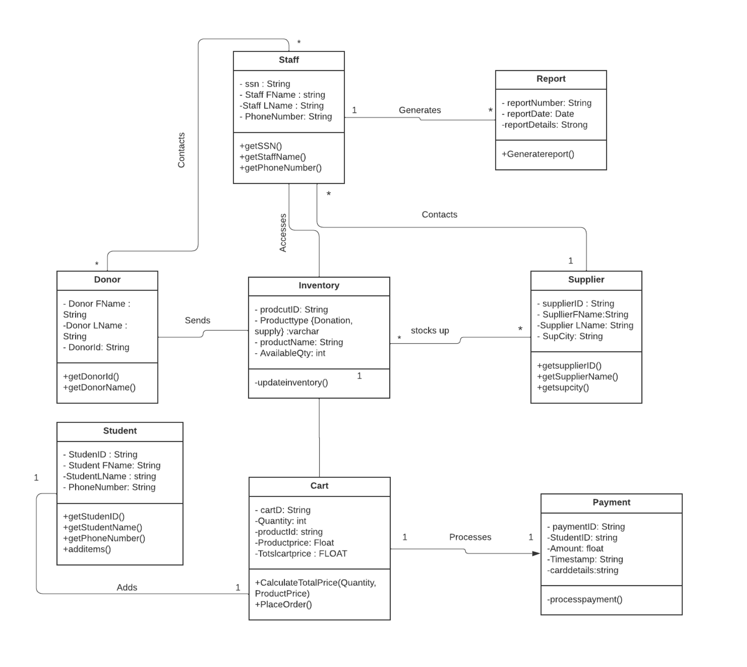

Here, we have removed all the duplicate values and have made them into atomic values to remove redundancy.

**2NF**

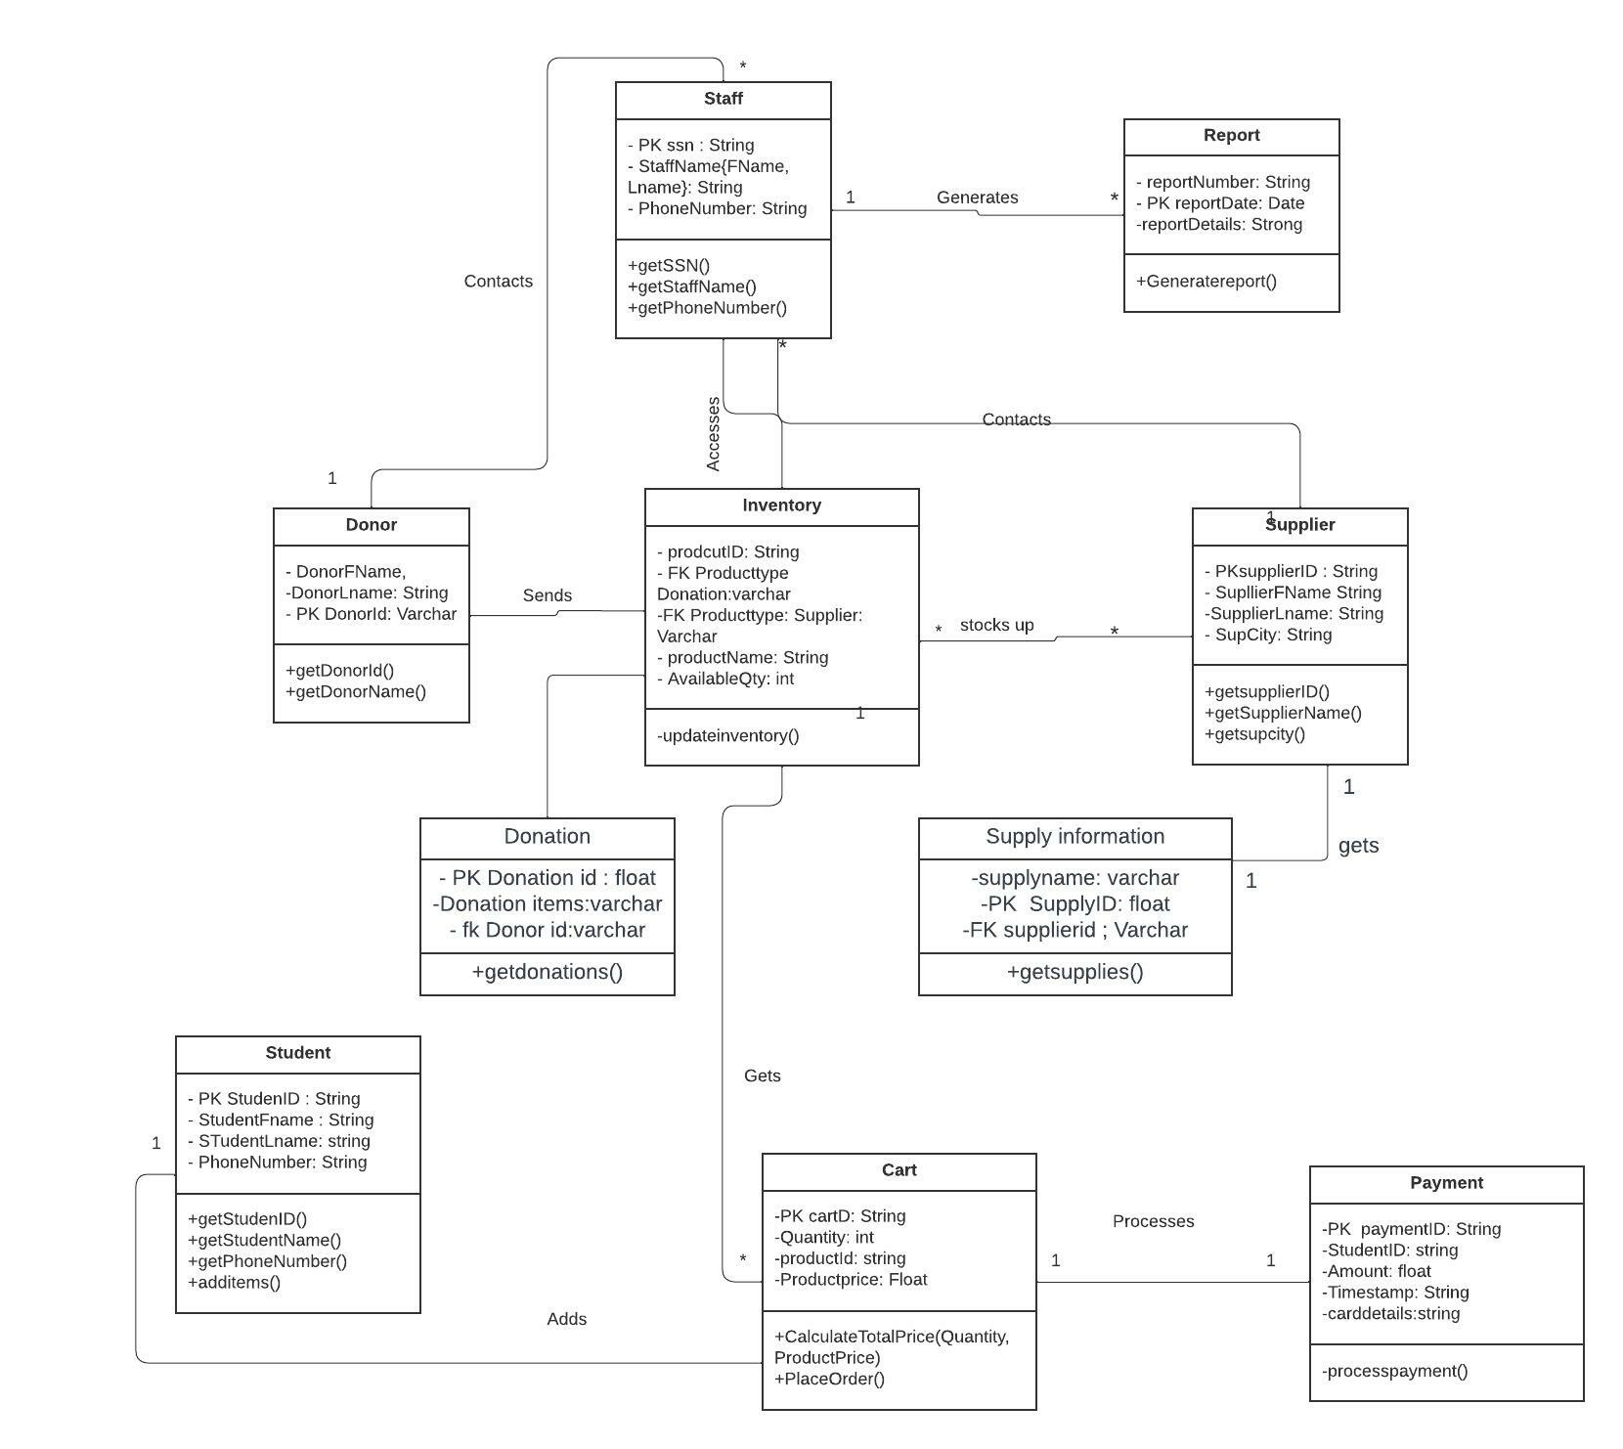

Here, the transitive dependencies have been removed

**PRIVACY COMPONENT**

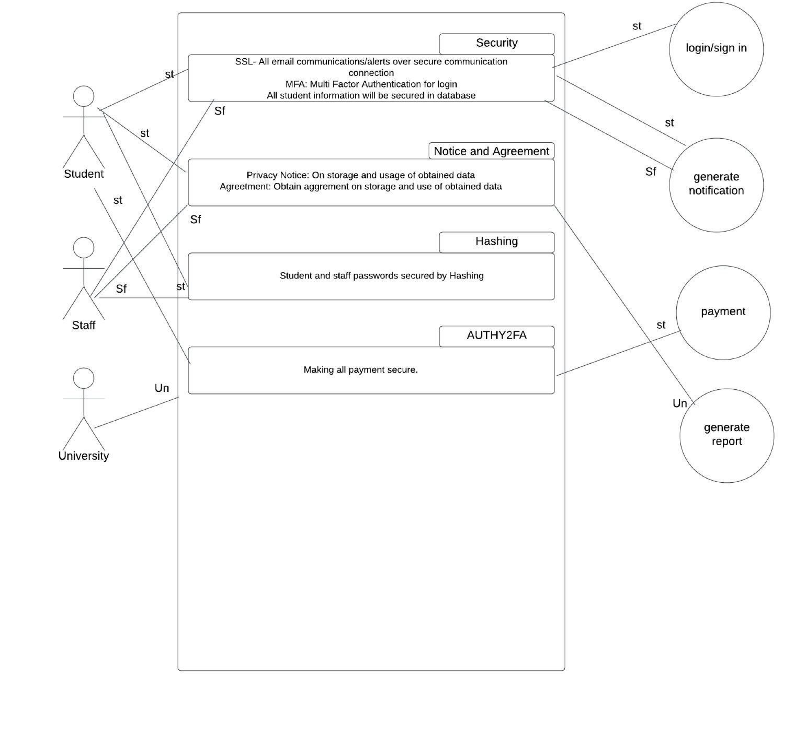

**PRIVACY COMPONENT**

This is one of the important components of our system which will protect our student's personal information. The Student, Staff and the university are the main actors in our privacy component diagram. All the communication and action between the actors are protected with some security tools.

First, while login in or Signing in to the system all the details are secured using security like SSL (Secure Sockets Layer)which is an encryption-based security protocol which will protect all email communication and alerts. And Multi-Factor Authentication (MFA) will help the student to log in safely to the app with their UMASS student email and password. All these details while logging in are secured in our app database.

Secondly, the password of the student and staff is secured using hashing technique. The password they entered is encrypted into short numbers or letters using an algorithm.

This above security will help to protect all communication and avoid Spam mail to the students and only authorized, registered students can have benefited from the services of U-access. There is a privacy notice on the data that is stored or used for data management for the university to keep track of the registered student, profit and loss from the store, etc.

Authy2fa for payment which is used in PayPal for secure transactions use google authentication. This above component used in the Use case diagram will help to protect the app from any malware or bug attack.

**WIREFRAMES**

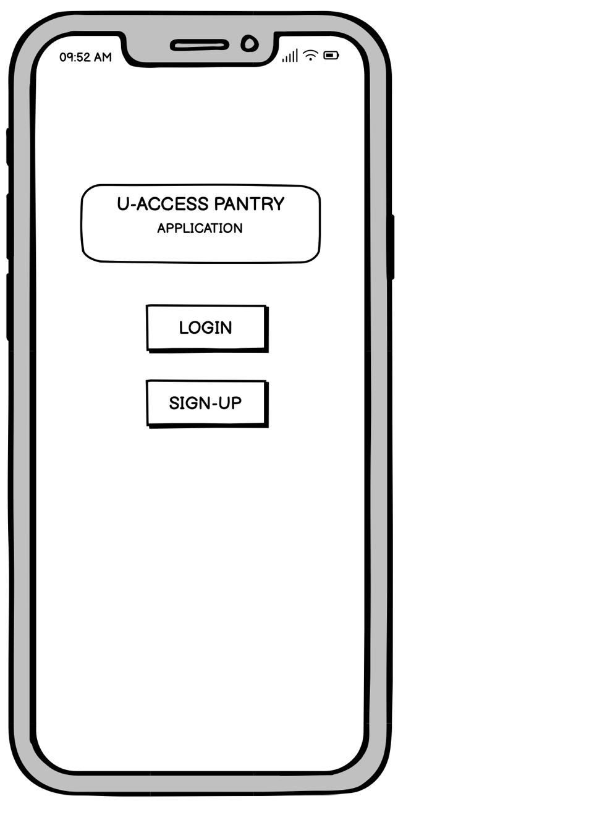

This is how the initial page will look like after the student has downloaded the application.

The page will show the Log in or Sign up option.

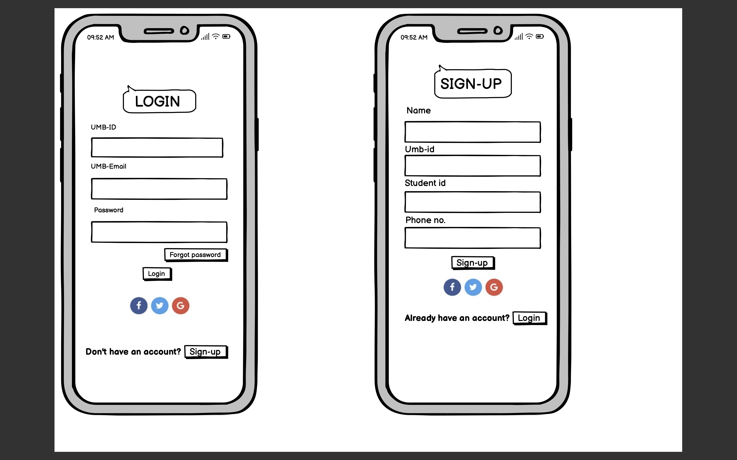

The student has the option of making an account if they don't already have one. The student just has to login to the application if they already have an account.

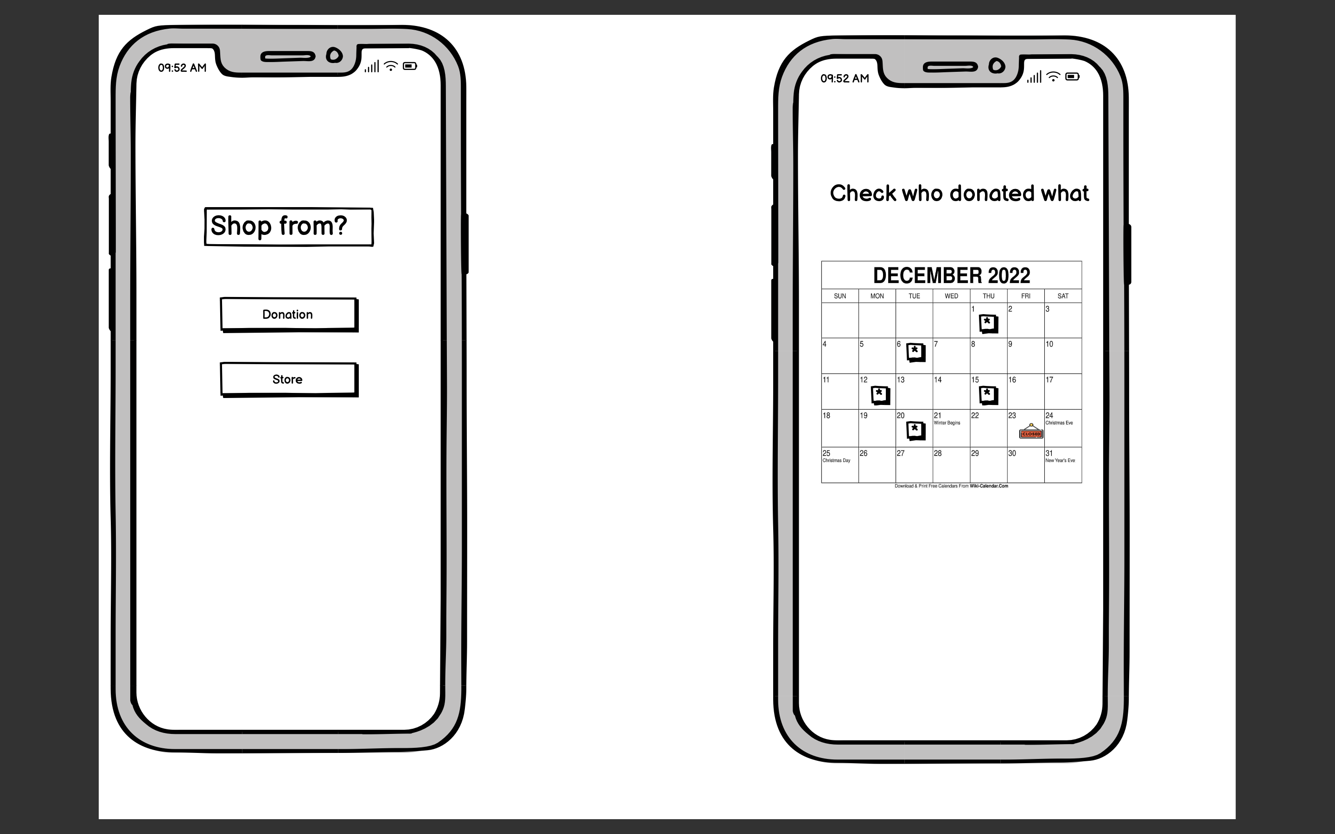

After the onboarding process a page that gives two options to the student i.e Donation and Store whichever the student prefers.

If the student selects the donation button a calendar will appear that shows who are the donors, what have they donated, how much and on what date.

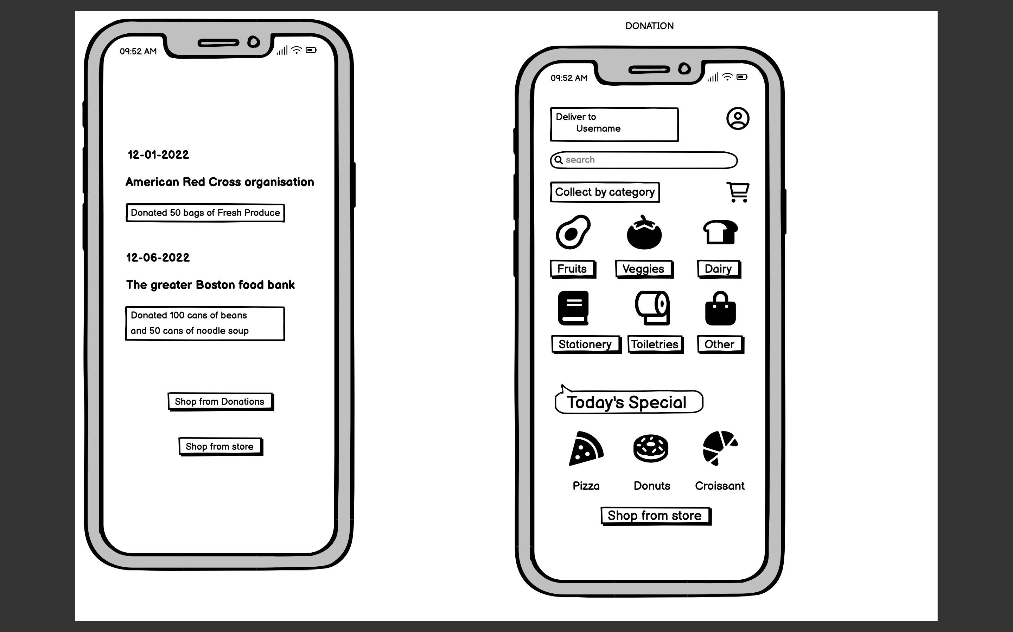

The first screen shows which all organisation have donated what in order to ensure transparency.

After that the student must select the “Shop from Donation” button and the second screen will appear, there the user has multiple options that he can choose.

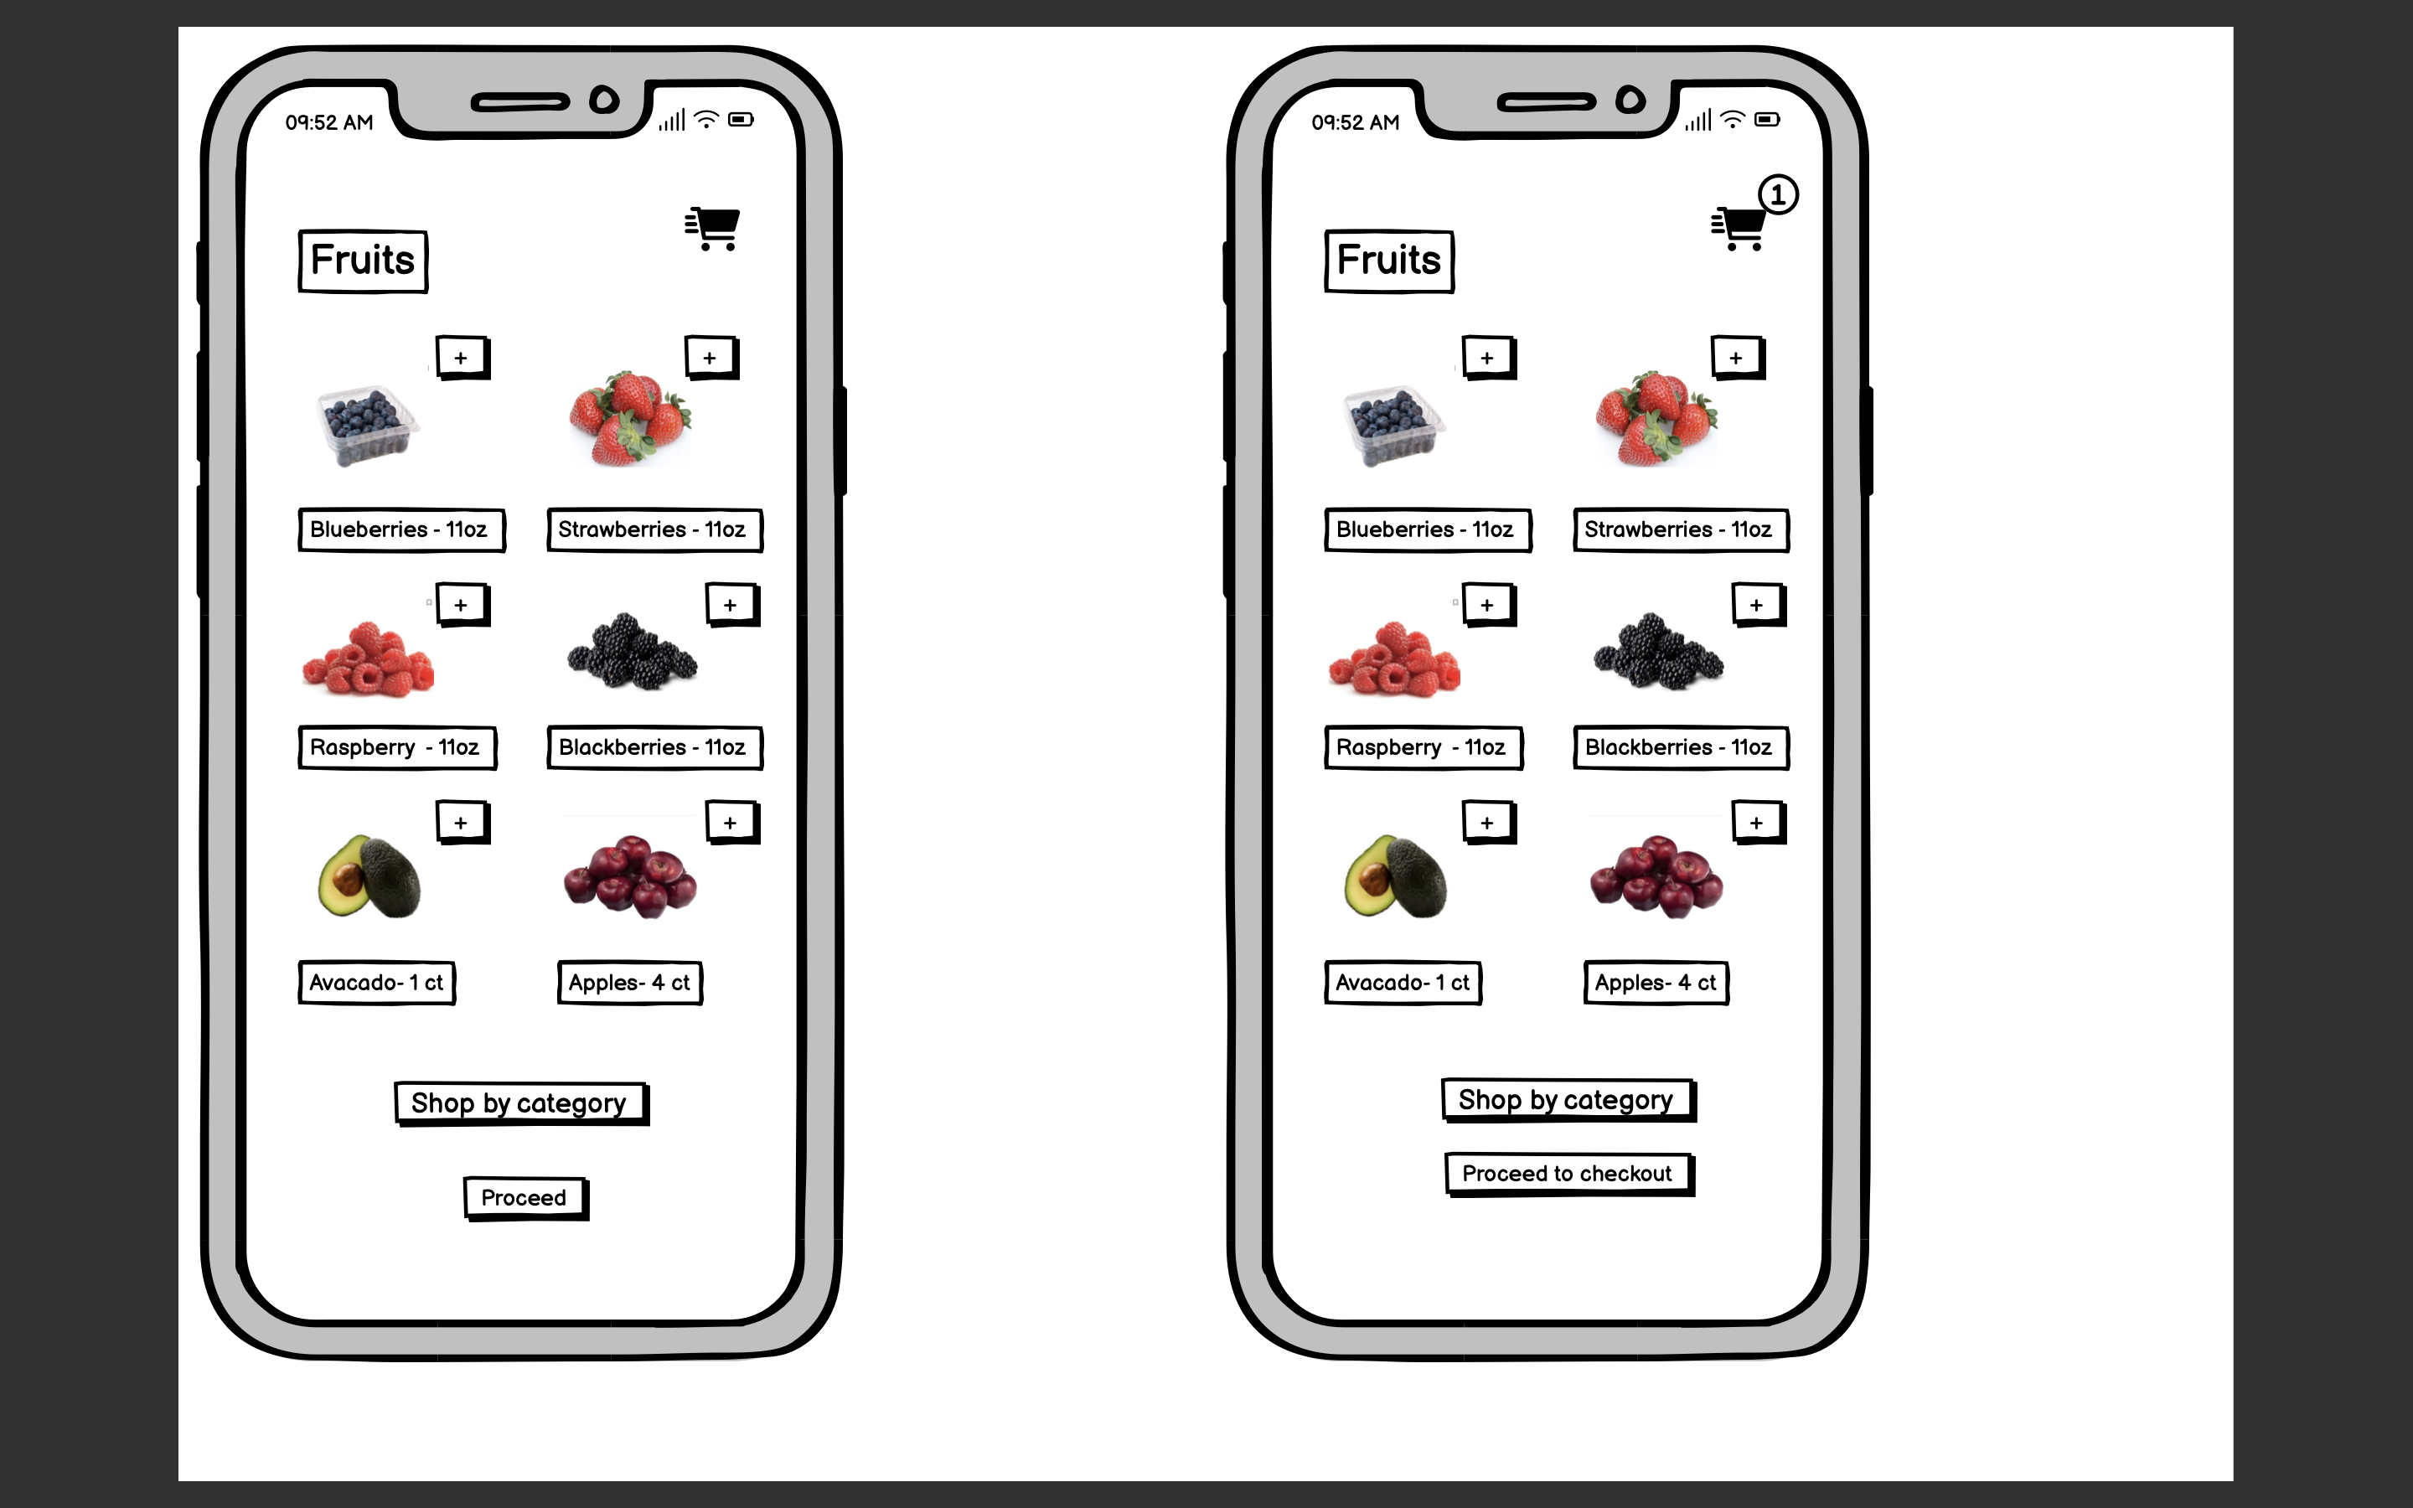

As you can see that since we had selected “shop from donations” there are is no price mentioned here. The user has to click the “+” button to add product to the cart.

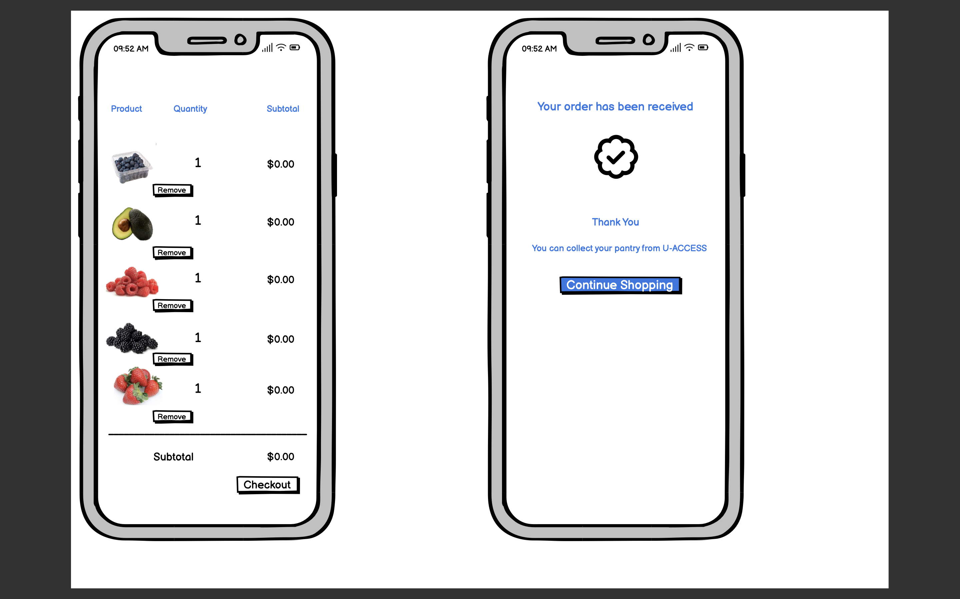

After the user is done adding items to the cart, the user simply has to select the “Checkout” button which will then notify the user that their order has been placed. The user also have a “continue shopping” button if they want to shop more from the store

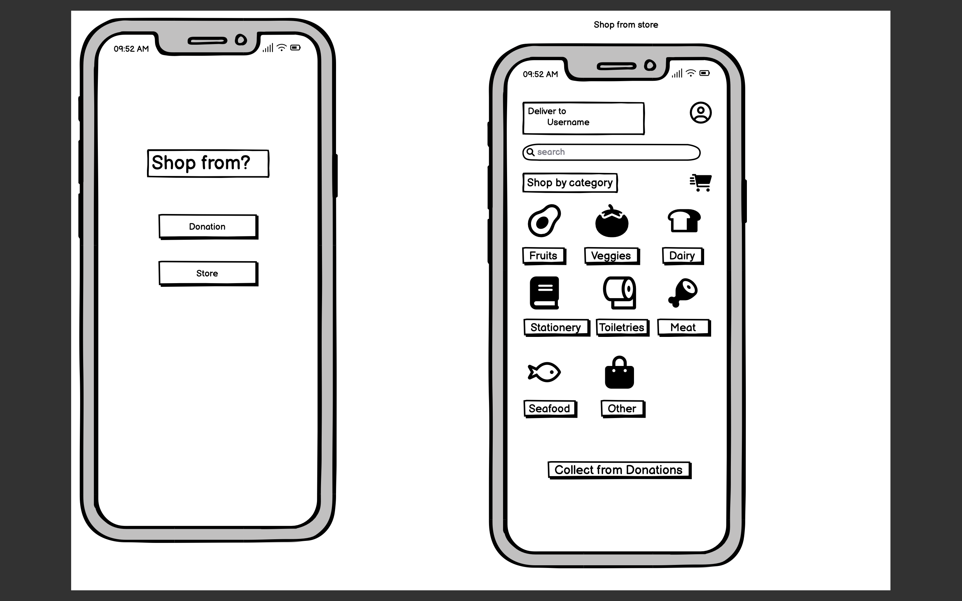

After clicking on the “continue shopping” button, the app will again take the user to the Shop from page where the user will have the two options mentioned above.

If the user selects the “ Store” button then the app will take the user to the store interface.

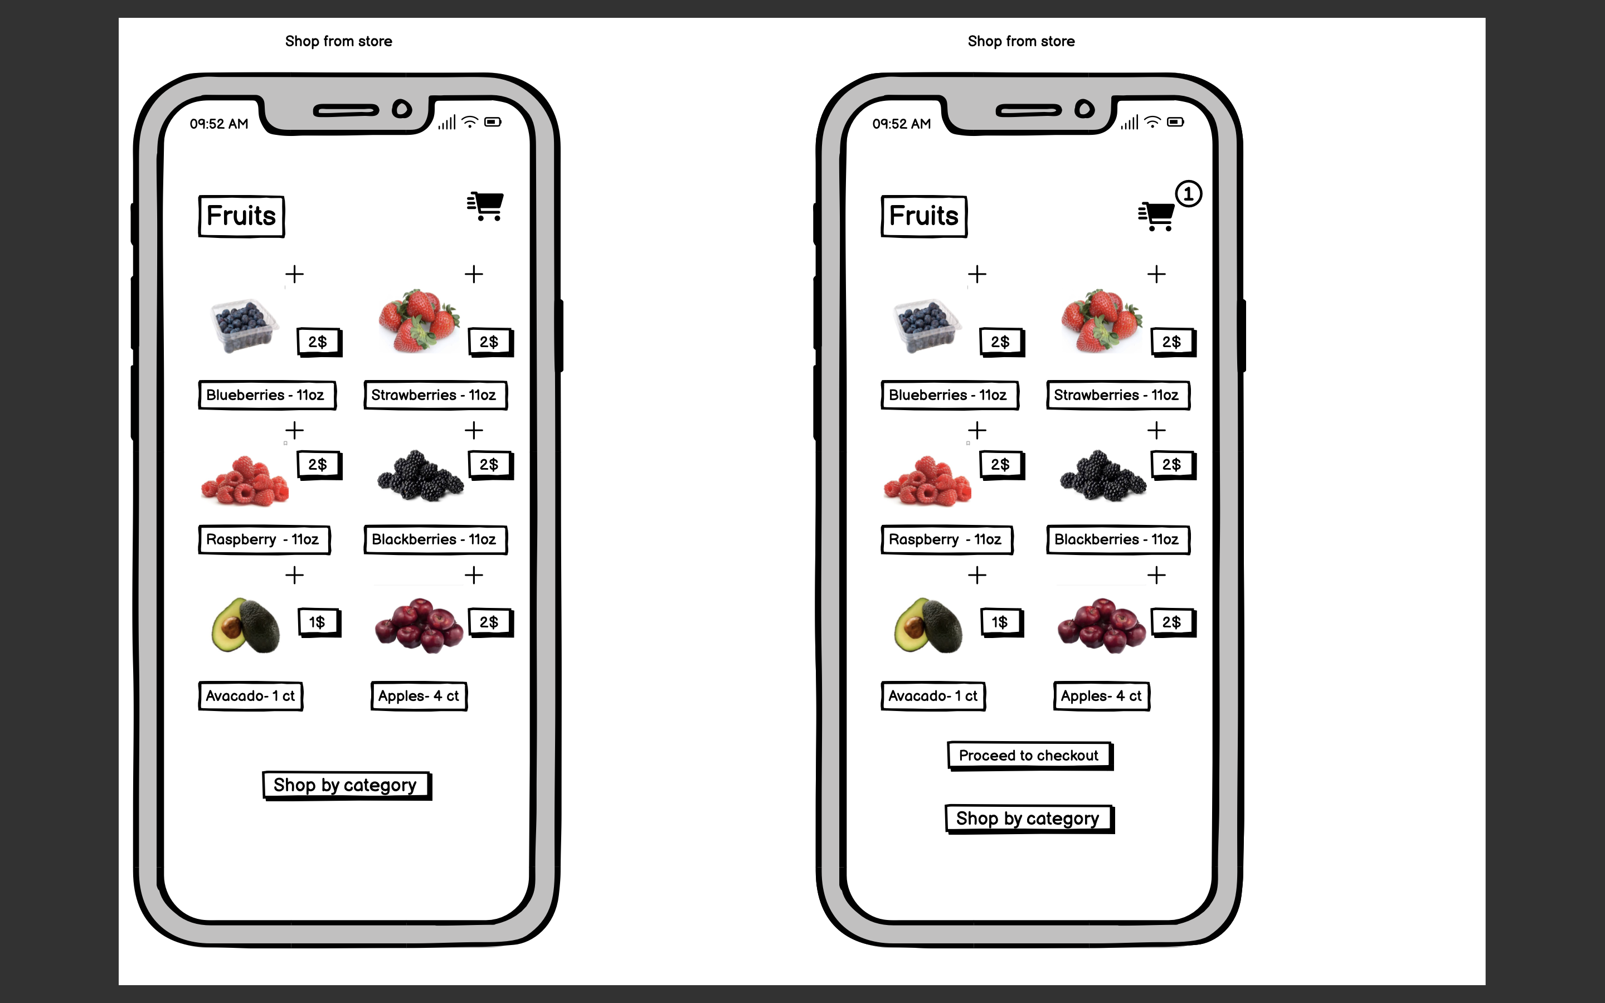

Since the user is now shopping groceries from the store there is price mentioned here. The user simply needs to add the items that they want to the cart and proceed to checkout.

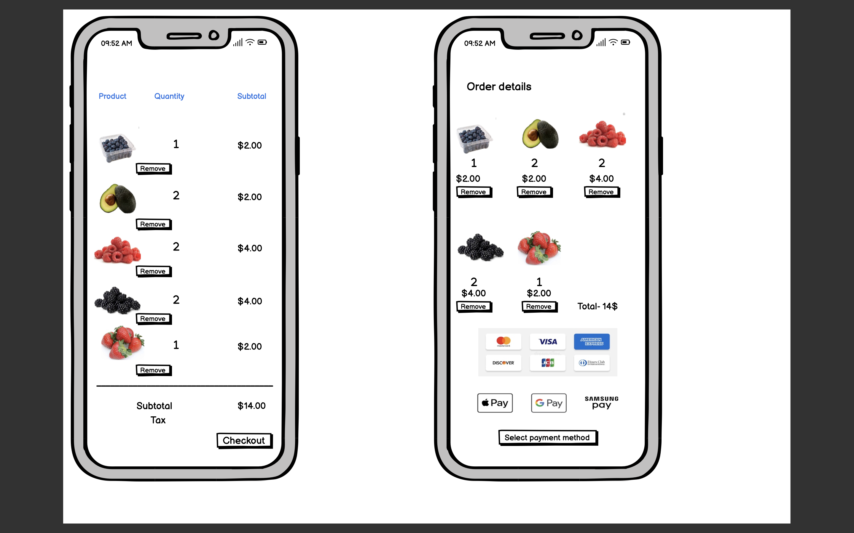

After the user had added items to the cart the user has to select a payment method.

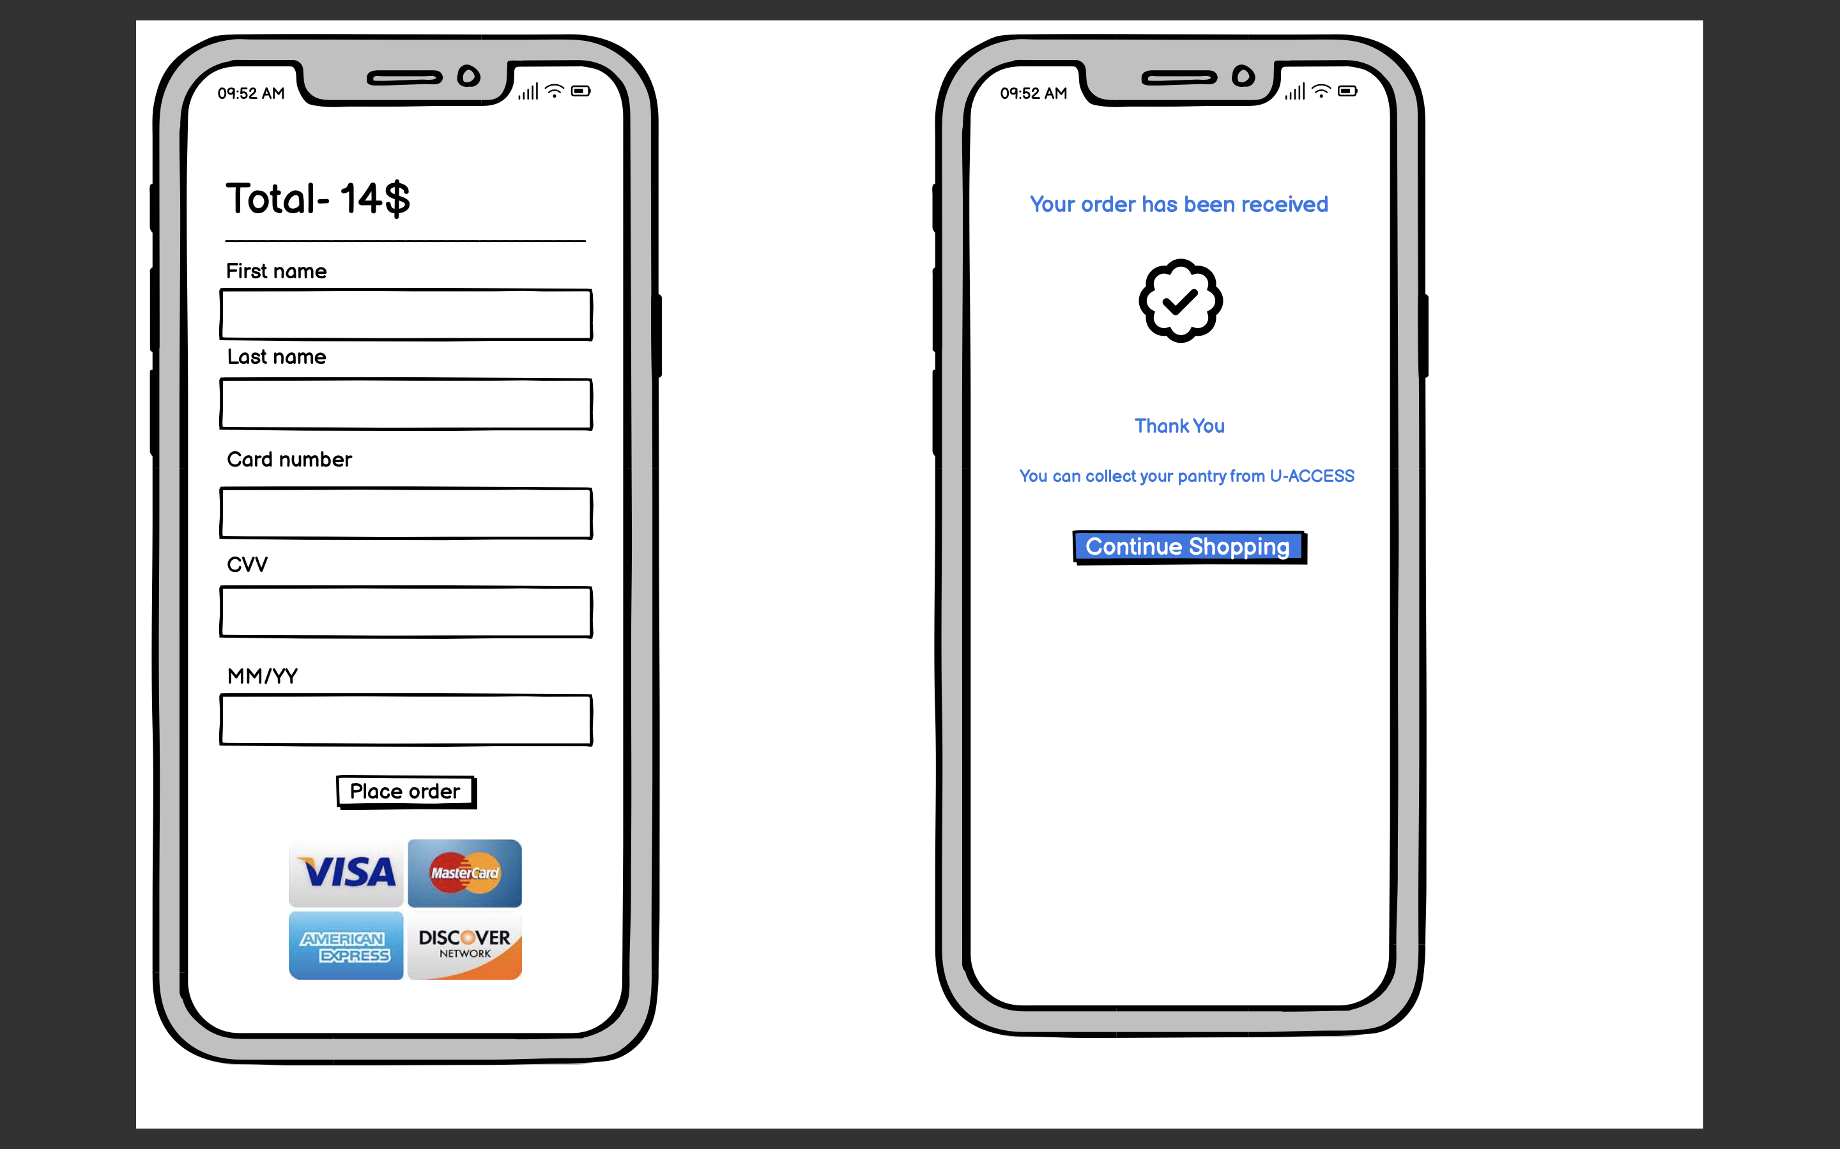

After the user selects the payment method the user has to enter their card details and place the order.

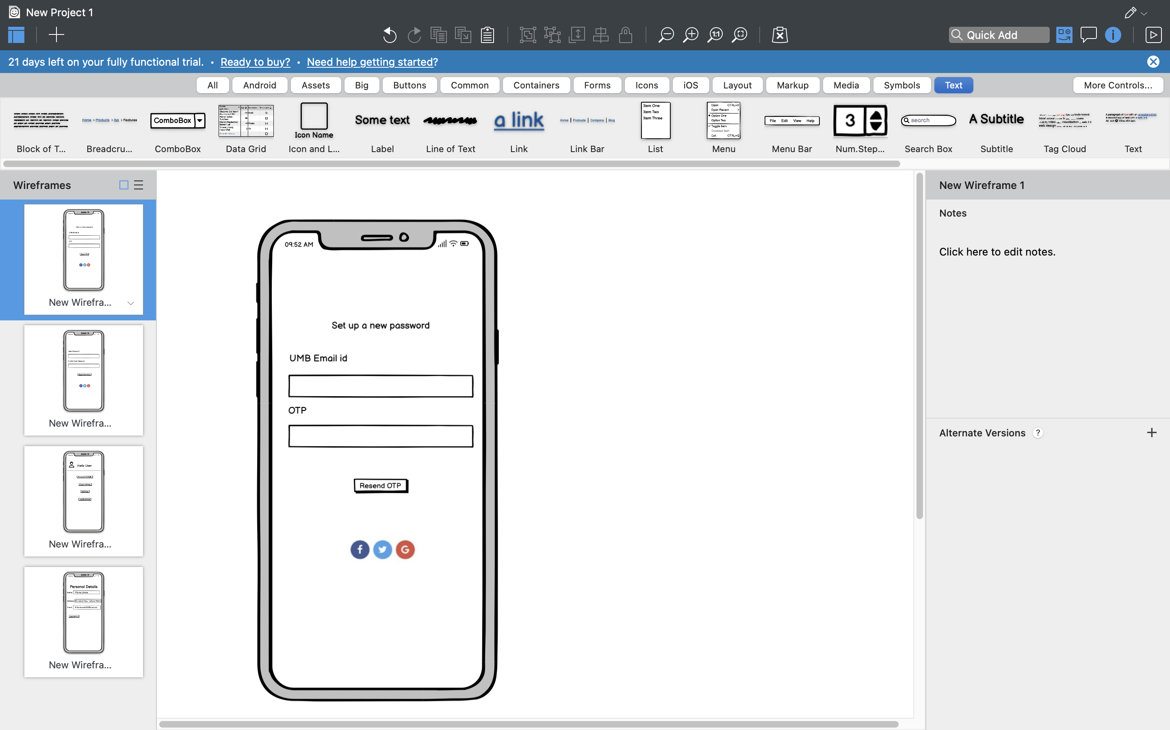 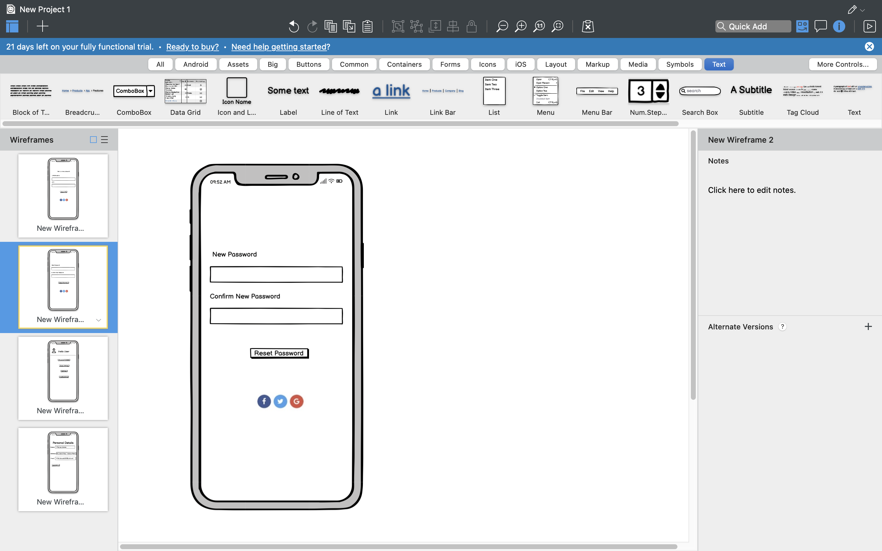

If in case the user forgets their password the user can reset their password buy entering their registered UMB id and the otp. This will allow the user to set a new password.

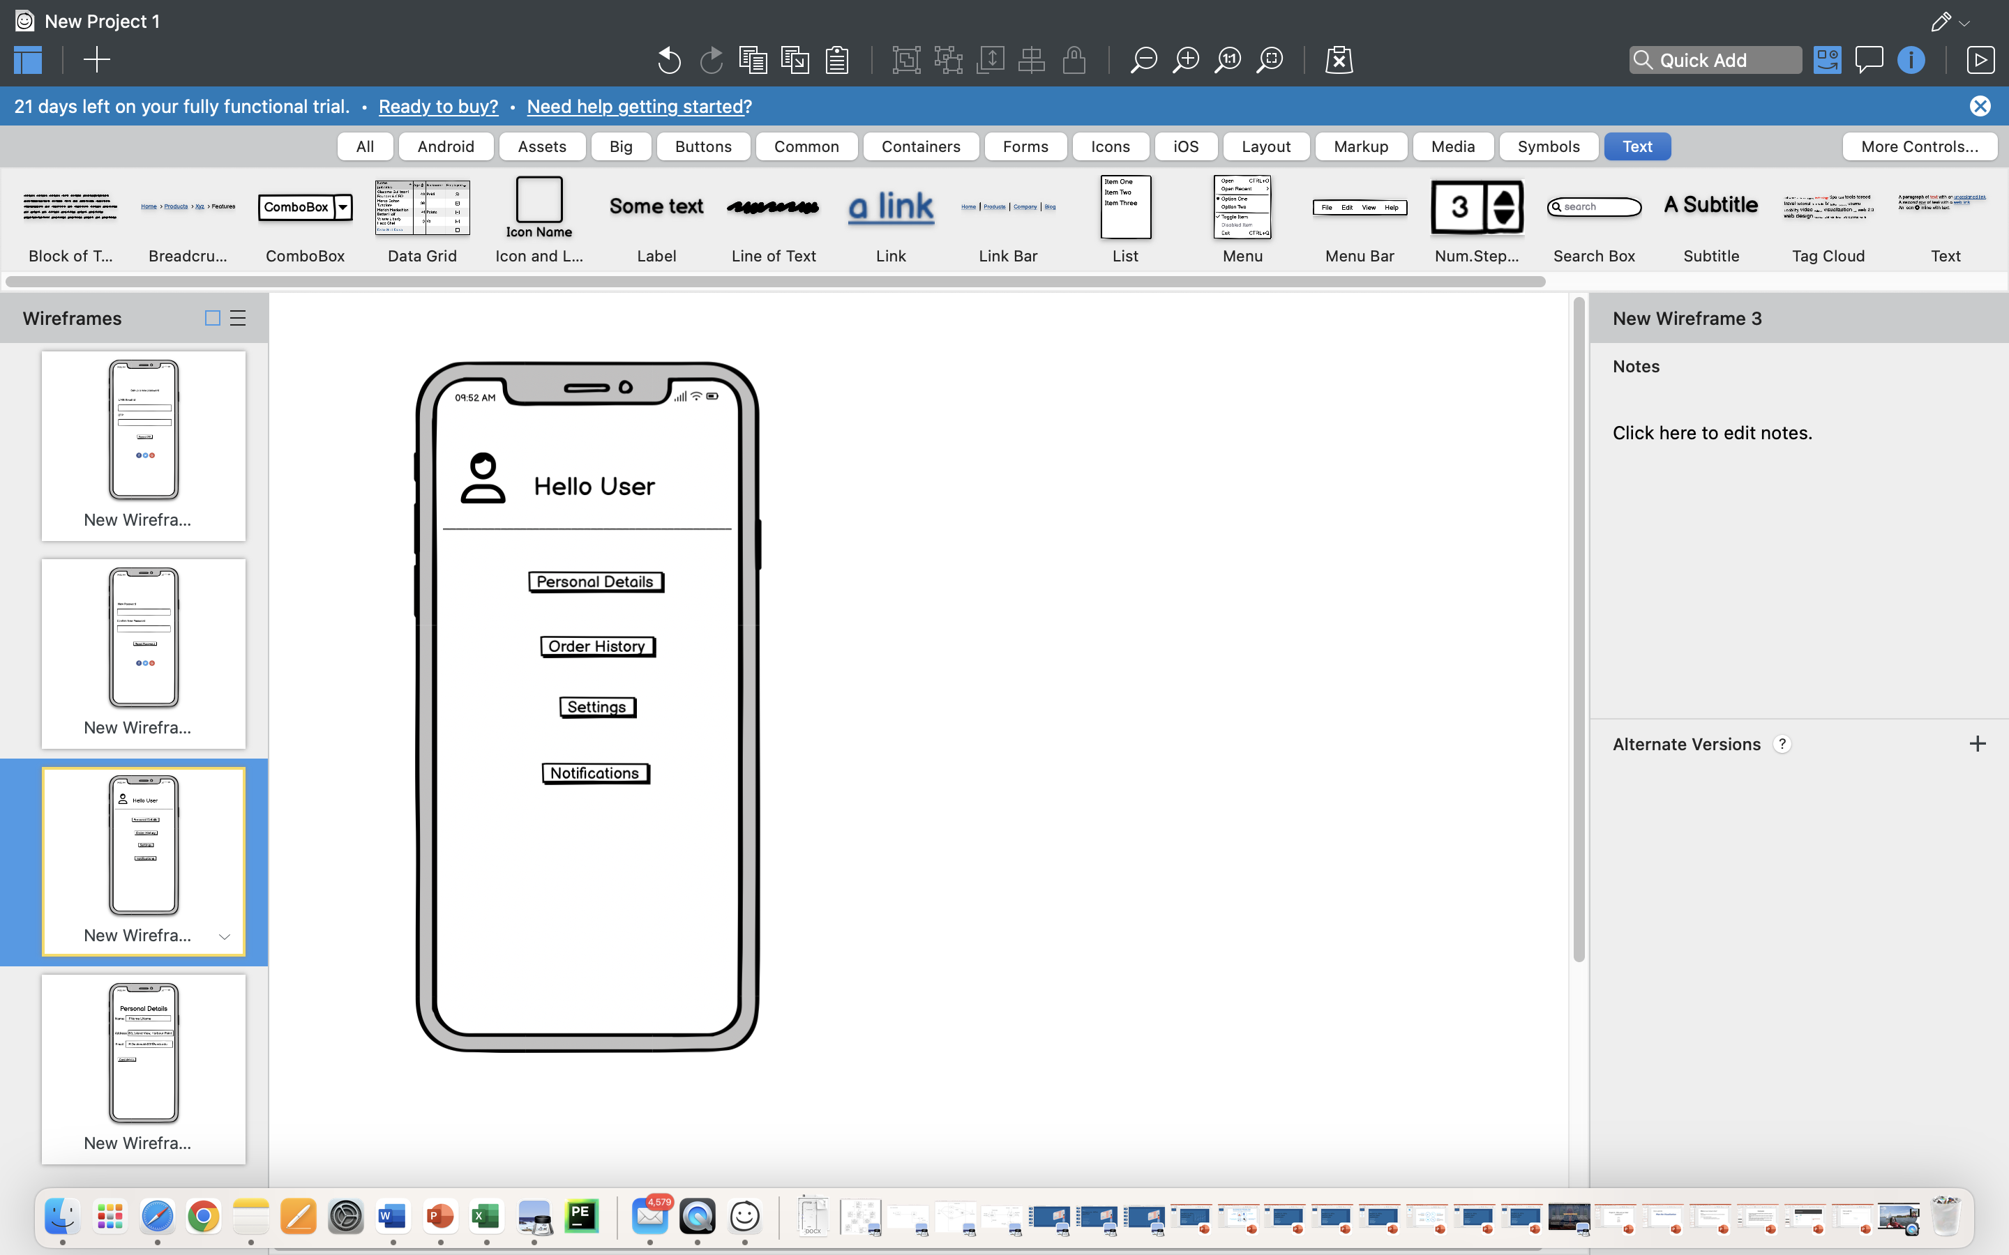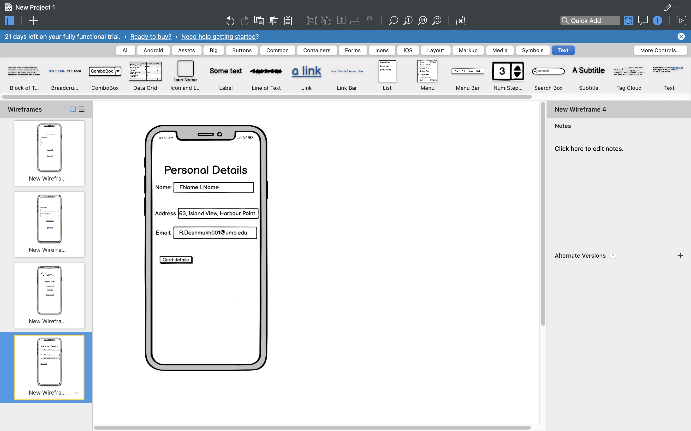

The user can also be able to view their personal details that they have registered by simply clicking on the user icon

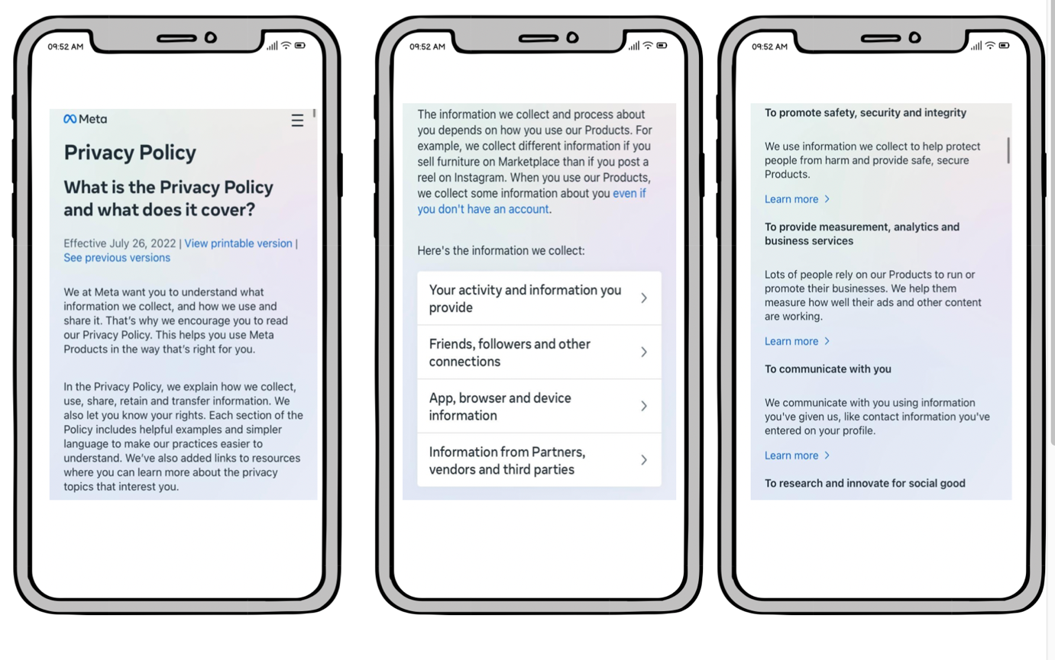

Privacy Policies of the app

**METHODOLOGY**

While Waterfall helps with the completion of a single project, Agile helps with the completion of several smaller projects. Even if creating an application is a single project, it contains several smaller projects or intricate capabilities like alert generation, safe student data storage, order placement, order request acceptance, and order notification. Waterfall focuses on effective project delivery, while Agile provides a product mindset with a focus on customer satisfaction .Agile projects frequently cost less money and are finished more quickly. Since many project components are ambiguous and vague, they offer greater flexibility but less predictable outcomes. Waterfall projects frequently cost more money and take longer to finish. Agile greatly decreases total project risk while maximizing value throughout the development process. The Agile model makes it possible to easily adopt changes while maintaining openness with donors, staff, and students. As soon as the first design is successful, products are created and integrated while adhering to customer requirements and generating cash through various self-funding initiatives. Agile ecommerce and data-driven decision-making techniques will help the university business  discover untapped markets and internal possibilities.

**Technical recommendations for implementing the project**

|  |  |  |
| --- | --- | --- |
| U-ACCESS | Technical Software | Reason for choosing |
| Application Development Platform | Android Studio using Java | Android Studio consistently appears at the top of developers' lists of favored tools. |
| Database | My SQL Workbench | To store the students, staff and donors data. To create a database where all the personal information can be tracked at one place and permissions can be granted on the conditions set |
| Operating Systems | Windows, Mac |  |
| Workflow diagrams | Lucid chart, Visual Studio | All the workflow diagram such as activity, state chart, sequence, class diagram can be created using these two tools. |
| Communication Platform | Zoom, Microsoft teams, Google meet | Workspace for team meetings & communication |

**A table summarizing how the feedback for the interim presentations was addressed**

|  |  |  |  |
| --- | --- | --- | --- |
| Date | Assignment number | Feedback from instructor | Response |
| 11/19/22 | Class diagram | Class diagrams are independent of technology. We do not identify data types for attributes in the class diagram. That is ER model. | We had redundant objects in the class diagram which we removed and updated the class diagram with accurate objects. |
| 10/26/22 | Data Flow Diagram | DFD and use cases have be to synchronized. Ensure all processes identified in DFDs are reflected in use case. | We had broken down level 0 DFD to level 1 for each and every process to the task level which was not necessary. Therefore we updated the DFD diagram as per the feedback from the professor |
| 10/18/22 | Use- case diagram | Determine if there are specializations/generalizations for both actors and use cases. Specialization is "is-a-kind-of" relation. For instance, if "Place order" is an abstract use case, then "Place order by phone" and "Place order online" could be two specialized use cases. Finally, identify the dependencies between use cases | We have updated the accurate include extend relationships for our use case diagram. |

|  |  |  |  |
| --- | --- | --- | --- |
| **Date** | **Assignment number** | **Feedback from instructor** | **Response** |
| 11/19/22 | Sequence diagram | In the sequence diagram, any new instance created must be created on the model. For instance, if a new order is created. | As per the feedback from the professor we have created an instance whenever a new order is created. |

**REFERENCES**

* In Massachusetts, the rate of food insecurity is approaching its May 2020 pandemic peak.

<https://www.projectbread.org/hunger-by-the-numbers>

* Student Services: U-ACCESS PANTRY

<https://www.umb.edu/life_on_campus/uaccess>

* What is two factor authentication

<https://authy.com/what-is-2fa/>